**Industrial**

# PROJECT REPORT

**Submitted By AYUSHI SRIVASTAVA**

# University Roll No 1900290140011

**Submitted in partial fulfilment of the Requirements for the Degree of**

**MASTER OF COMPUTER APPLICATION**

# Under the Supervision of Ms. Neelam Rawat ASSOCIATE PROFESSOR



**Submitted to**

**DEPARTMENT OF COMPUTER APPLICATIONS**

**KIET Group of Institutions Ghaziabad Uttar Pradesh-201206 (June 2022)**

# DECLARATION

I hereby declare that the work presented in this report entitled **“Fulflex”**, was carried out by me. I have not submitted the matter embodied in this report for the award of any other degree or diploma of any other University or Institute.

I have given due credit to the original authors/sources for all the words, ideas, diagrams, graphics, computer programs, experiments, results, that are not my original contribution. I have used quotation marks to identify verbatim sentences and given credit to the original authors/sources.

I affirm that no portion of my work is plagiarized, and the experiments and results reported in the report are not manipulated. In the event of a complaint of plagiarism and the manipulation of the experiments and results, I shall be fully responsible and answerable.

Name: Ayushi Srivastav Roll No: 1900290140011

Branch: MCA

**(Candidate Signature)**

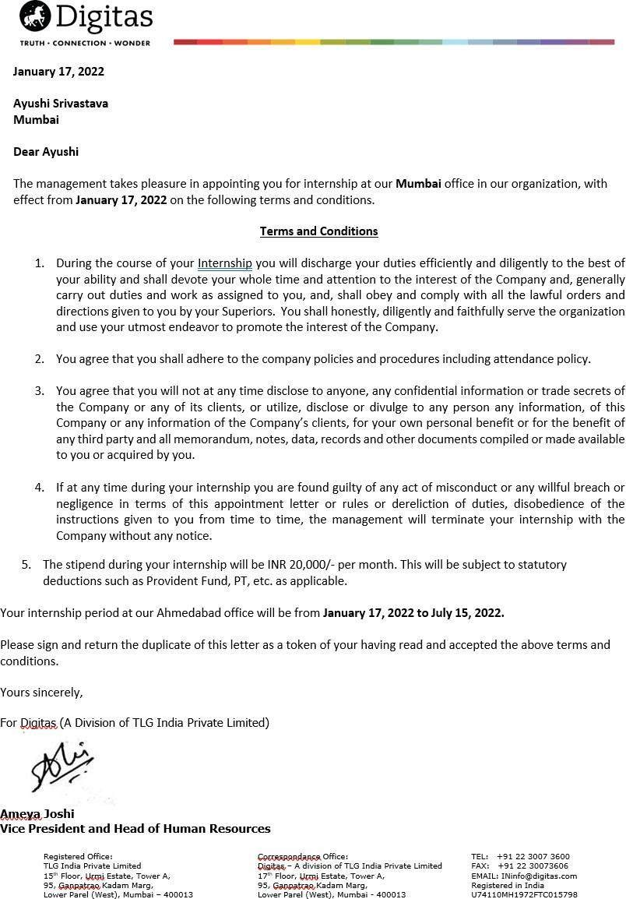

# CERTIFICATE

Certified that **Ayushi Srivastava** (**Enrollment no. 190029014005154**) have carried out the project work having **“Fulflex”** for Master of Computer Applications from Dr. A.P.J. Abdul Kalam Technical University (AKTU) (formerly UPTU), Technical University, Lucknow under my supervision. The project report embodies original work, and studies are carried out by the student himself/herself and the contents of the project report do not form the basis for the award of any other degree to the candidate or to anybody else from this or any other University/Institution.

### Date:

This is to certify that the above statement made by the candidate is correct to the best of my knowledge.

### Date:

**Ms. Neelam Rawat Associate Professor**

### Department of Computer Applications KIET Group of Institutions, Ghaziabad

**Signature of Internal Examiner Signature of External Examiner**

### ABSTRACT

It is good source of inter activity among students and also between the teacher and students. It is done in order to improve student’s learning motivation.

Fulflex is a manufacturer Elastic product. It offers elastic tapes, threads, and films, tourniquets, and esmark bandages.

Fulflex is a subsidiary of Garflex Inc. They are a top brand company that provides rubber sheeting & strips, engineered rubber tape & sheets etc.

This website is the world's leading manufacturer of calendered elastic tapes & rubber sheets. Our products include industrial elastic, thread, stretch, Elastotec etc

Fulflex is the most preferred supplier to Fortune 500 companies exporting to over 85 countries around the world.

Fulflex is founded in 1932 and it is a private firm where product are supplier over 85 countries.

Fulflex is a manufacturer elastic product. It offers elastic tapes, threads, and films, tourniquets, and Esmark bandages. The company caters to medical, textile, food, industrial, and other sectors. Fluflex processing capabilities include filtration, calendaring, splicing, pre- stretching, and custom rubber mixing.

Fulflex is headquartered in Brattleboro, United States.

# ACKNOWLEDGEMENTS

Success in life is never attained single handily. My deepest gratitude goes to my thesis supervisor, Dr. Vipin Kumar for his guidance, help and encouragement throughout my research work. Their enlightening ideas, comments, and suggestions.

Words are not enough to express my gratitude to Dr. Ajay Kumar Shrivastava, Professor and Head, Department of Computer Applications, for his insightful comments and administrative help at various occasions.

Fortunately, I have many understanding friends, who have helped me a lot on many critical conditions.

Finally, my sincere thanks go to my family members and all those who have directly and indirectly provided me moral support and other kind of help. Without their support, completion of this work would not have been possible in time. They keep my life filled with enjoyment and happiness.

**Ayushi Srivastava**

# Table of Contents

|  |  |  |
| --- | --- | --- |
| **S.No.** | Tittle | Page |
|  | DECLARATION | ii |
|  | CERTIFICATE | iii |
|  | ABSTRACT | iv |
|  | ACKNOWLEDGEMENTS | v |
|  | Table of Contents | vii |
| **CHAPTER 1** | **INTRODUCTION** | 9 |
| 1.1 | PROJECT DESCRIPION | 9 |
| 1.2 | PROJECT SCOPE | 9 |
| 1.3 | Hardware/ Software used in project | 10 |
| **CHAPTER 2** | **TECHNICAL FEASIBILITY** | 12 |
| 2.1 | Technical feasibility | 13 |
| 2.2 | Technology Description | 14 |
| 2.1.1 | HTML | 15 |
| 2.1.2 | CSS | 17 |
| 2.1.3 | jQuery | 18 |
| 2.1.4 | Bootstrap | 22 |
| 2.1.5 | JavaScript | 26 |
| 2.3 | Technology used in project | 41 |
| **CHAPTER 3** | **Backend Design** | 42 |
| 3.1 | MySQL | 43 |
| 3.2 | Database views | 44 |
| 3.3 | Drupal | 45 |
| 3.4 | CMS | 46 |
| **CHAPTER 4** | **Frontend Design** | 47 |
| 4.1 | Input / Output Form (Screenshot) | 60 |
| **CHAPTER 5** | **Report** | 61 |

|  |  |  |
| --- | --- | --- |
| 5.1 | Report / output (Screenshot) | 66 |
| **CHAPTER 6** | **Testing** | 67 |
| 6 | Test case | 69 |
| 6.1 | Unit Testing | 71 |
| 6.2 | Integration Testing | 72 |
| 6.3 | Performance Testing | 78 |
| **CHAPTER 7** | **Limitation** | 79 |
| 7.1 | Future scope | 80 |
| 7.2 | Future Enhancement | 80 |
| **CHAPTER 8** | **Conclusion** | 81 |
| **CHAPTER 9** | REFERENCE | 82-83 |

**CHAPTER 1 INTRODUCTION**

### PROJECT DESCRIPION

Fulflex is the world's leading manufacturer of calendered elastic tapes & rubber sheets. Our products include industrial elastic, thread, stretch, etc.

Our products include industrial, medical, textile, food, industrial, and other sectors.

Fulflex is a subsidiary of Garflex Inc. We are a top brand company that provides rubber sheeting & strips, engineered rubber tape & sheets, elastic etc.

Fulflex is a manufacturer elastic product. It offers elastic tapes, threads, and films, tourniquets, and esmark bandages.

The company caters to medical, textile, food, industrial, and other sectors.

Fluflex processing capabilities include filtration, calendaring, splicing, pre-stretching, and custom rubber mixing.

The company utilizes natural and synthetic polymers to produce the finest custom- manufactured elastic tapes, and threads which are used in a variety of apparel – swimwear, underwear, sportswear; and children’s wear and in disposable diapers; healthcare products; fitted bedsheets; luggage sets; vacuum cleaner bags and golf balls. Fulflex also provides the graphic arts industry with compounds which can be module, hand or laser-engraved.

### PROJECT SCOPE

The worldwide leadership of Fulflex grew out of a strong commitment to research and development. The company provides its customers with specialist engineering and sales people capable of analysing difficult production problems.

Additionally, Fulflex technical expertise extends to product packaging and one of the company’s specialties is to engineer and develop packaging systems, which ensures that the products therein arrive tangle-free and ready to use, thus eliminating production down-time.

Fulflex elastic tapes, and threads helps improve the user experience, optimizing comfort, fit and performance of your solutions. Many of the world’s leading brand names rely on Fulflex to provide the “suppleness, strength, stretch, comfort, and fit in the diverse range of products where Fulflex elastic is used.

### Hardware/ Software used in project

**Hardware:**

The most common set of requirements defined by any operating system

or software application is the physical computer resources, also known as hardware. Memory – All software, when run, resides in the Random Access Memory (RAM) of a computer. Memory requirements are defined after considering demands of the application, operating system, supporting software and files, and other running processes. Optimal performance of other unrelated software running on a multi- tasking computer system is also considered when defining this requirement.

Hardware requires software to run correctly. **Without the correct hardware, your software may not run efficiently or at all**. It is important to consider both when making decisions about your IT systems, as this can affect the way you work, your productivity and your business' bottom line.

|  |  |  |
| --- | --- | --- |
| **Name** | **Type** | **Description** |
| 1 | SSD | PC with 250 GB or more Hard disk |
| 2 | RAM | PC with 2 GB RAM. |
| 3 | PC | PC with Pentium 1 and above**.** |
| 4 | Operating  System | Windows XP / Windows |
| 5 | Language | HTML,CSS, and Jquery |
| 6 | Database | My Sql 5 , MariaDB 10.3.32 |
| 7 | Cloud  Services | AWS, SES, CloudFront CDN, AWS S3 |

# Software:

The software requirements are description of features and functionalities of the target system. Requirements convey the expectations of users from the software product.

The requirements can be obvious or hidden, known or unknown, expected or unexpected from client’s point of view.

Every project need software. We should try to understand what sort of requirements may arise in the requirement elicitation phase and what kinds of requirements are expected from the software system.

|  |  |  |
| --- | --- | --- |
| **Number** | **Description** | **Type** |
| 1 | Operating System | Windows XP / Windows |

|  |  |  |
| --- | --- | --- |
| 2 | Front End: | HTML, CSS & jQuery |
| 3 | Back End: | CMS Drupal 9.0, PHP 7.4 & jQuery |
| 4 | Database Used: | Mysql5 & MariaDB 10.3.32 |
| 5 | Web Server: | Nginx, PHP-FPM, PHP 7+ |
| 6 | Cloud Services: | AWS SES, AWS CloudFront CDN, AWS S3 |

# CHAPTER 2 FEASIBILITY STUDY

A feasibility study is a high-level capsule version of the entire System analysis and Design

Process. The study begins by classifying the problem definition.

Feasibility is to determine if it’s worth doing. Once an acceptance problem definition hasbeen generated, the analyst develops a logical model of the system. A search for alternatives is analyzed carefully.There are 3 parts in feasibility study.

### TECHNICAL FEASIBILITY

This involves questions such as whether the technology needed for the system exists, how difficult it will be to build, and whether the firm has enough experience using that technology. The assessment is based on outline design of system requirements in terms of input, processes, output, fields, programs and procedures. This can be qualified in terms of volume of data, trends, frequency of updating in order to give an introduction to the technical system. The application is the fact that it has been developed on windows XP platform and a high configuration of 1GB RAM on Intel Pentium Dual core processor. This is technically feasible.

### TECHNOLOGY DISCRIPTION 2.1.1HTML:

The Hyper Text Markup Language or HTML is the standard markup language for documents designed to be displayed in a web browser. It can be assisted by technologies such as Cascading Style Sheets (CSS) and scripting languages such as JavaScript.

Web browsers receive HTML documents from a web server or from local storage and render the documents into multimedia web pages. HTML describes the structure of a web page semantically and originally included cues for the appearance of the document.

HTML can embed programs written in a scripting language such as JavaScript, which affects the behavior and content of web pages. Inclusion of CSS defines the look and layout of content.

The World Wide Web Consortium (W3C), former maintainer of the HTML and current maintainer of the CSS standards, has encouraged the use of CSS over explicit presentational HTML since 1997.

A form of HTML, known as HTML5, is used to display video and audio, primarily using the

<canvas> element, in collaboration with JS.

HTML is a markup language used by the browser to manipulate text, images, and other content, in order to display it in the required format. HTML was created by Tim Berners-Lee in 1991. The first-ever version of HTML was HTML 1.0, but the first standard version was HTML 2.0, published in 1999.

**Elements and Tags:**

HTML uses predefined tags and elements which tell the browser how to properly display the content. Remember to include closing tags. If omitted, the browser applies the effect of the opening tag until the end of the page.

## HTML page structure:

The basic structure of an HTML page is laid out below. It contains the essential building-block elements (i.e. doctype declaration, HTML, head, title, and body elements) upon which all web pages are created.

## <!DOCTYPE html>:

This is the document type declaration (not technically a tag). Itv declares a document as being an HTML document. The doctype declarationis not case-sensitive.

## <html>:

This is called the HTML root element. All other elements are contained within it.

## <head>:

The head tag contains the “behind the scenes” elements for a web-page. Elements within the head aren’t visible on the front-end of a web-page. HTML elements used inside the <head> element include:

* <style>
* <title>
* <base>
* <script>
  + - <meta>
* <link>

### <body>:

The body tag is used to enclose all the visible content of a web-page. In other words, the body content is what the browser will show on the front- end. An HTML document can be created using any text editor. Save the textfile using

.html or .htm. Once saved as an HTML document, the file can be opened as a web-page in the browser.

**NOTE:** Basic/built-in text editors are Notepad (Windows) and Text-Edit (Macs). Basic text editors are entirely sufficient for when you’re just getting started. As you progress, there are many feature-rich text editors available which allow for greater function and flexibility.

# CSS:

Cascading Style Sheets (CSS) is a style sheet language used for describing the presentation of a document written in a markup language such as HTML.

CSS is a cornerstone technology of the World Wide Web, alongside HTML and JavaScript.

CSS is designed to enable the separation of presentation and content, including layout, colors, and fonts.

This separation can improve content accessibility; provide more flexibility and control in the specification of presentation characteristics; enable multiple web pages to share formatting by specifying the relevant CSS in a separate.

CSS file, which reduces complexity and repetition in the structural content; and enable the

.CSS file to be cached to improve the page load speed between the pages that share the file and its formatting.

CSS information can be provided from various sources. These sources can be the web browser, the user, and the author.

The information from the author can be further classified into inline, media type, importance, selector specificity, rule order, inheritance, and property definition.

CSS style information can be in a separate document, or it can be embedded into an HTML document. Multiple style sheets can be imported.

Different styles can be applied depending on the output device being used; for example, the screen version can be quite different from the printed version, so that authors can tailor the presentation appropriately for each medium.

The style sheet with the highest priority controls the content display. Declarations not set in the highest priority source are passed on to a source of lower priority, such as the user agent style. The process is called cascading.

### Who Creates and Maintains CSS? CSS Versions

Cascading Style Sheets level 1 (CSS1) came out of W3C as a

recommendation in December 1996. This version describes the CSS language as well asa simple visual formatting model for all the HTML tags. CSS2 became a W3C recommendation in May 1998 and builds on CSS1.

This version adds support for media-specific style sheets e.g., printers and aural devices, downloadable fonts, element positioning and tables.

### Bootstrap

Bootstrap is a free and open-source CSS framework directed at responsive, mobile-first front-end web development. It contains CSS- and (optionally) JavaScript- based design templates for typography, forms, buttons, navigation and other interface components. Bootstrap is the third-most starred project on GitHub, with more than 135,000 stars, behind only free Code Camp (almost 305,000 stars) and marginally behind Vue.js framework. According to Alexa Rank, Bootstrap getbootstrap.com is in the top-2000 in US while vuejs.org is in top-7000 in US. Bootstrap is a web framework that focuses on simplifying the development of informative web pages (as opposed to web apps). The primary purpose of adding it to a web project is to apply Bootstrap's choices of colour, size, font and layout to that project. As such, the primary factor is whether the developers in charge find those choices to their liking. Once added to a project, Bootstrap provides basic style definitions for all HTML elements. The result isa uniform appearance for prose, tables and form elements across web browsers. In addition, developers can take advantage of CSS classes defined in Bootstrap to further customize the appearance of their contents. For

example, Bootstrap has provisioned for light- and dark-colored tables, page headings, more prominent pull quotes, and text witha highlight. Bootstrap is a web framework that focuses on simplifying the development of informative web pages (as opposed to web apps). The primary purpose of adding it toa web project is to apply Bootstrap's choices of color, size, font and layout to that project. As such, the primary factor is whether the developers in charge find those choices to their liking. Once added to a project, Bootstrap provides basic style definitions for all HTML elements.

The result is a uniform appearance for prose, tables and form elements across web browsers. In addition, developers can take advantage of CSS classes defined in Bootstrap to further customize the appearance of their contents. For example, Bootstrap has provisioned for light- and dark- coloured tables, page headings, more prominent pull quotes, and text with a highlight.

Bootstrap was developed by Mark Otto and Jacob Thornton at Twitter.It was released as an open-source product in August 2011 on GitHub. In June 2014 Bootstrap was the No.1 project on GitHub.

### Why use Bootstrap

Following are the main advantage of Bootstrap:

* It is very easy to use. Anybody having basic knowledge of HTML and CSS can use Bootstrap.
* It facilitates users to develop a responsive website.
* It is compatible on most of browsers like Chrome, Firefox, Internet Explorer, Safari and Opera etc.

### What is a responsive website?

A website is called responsive website which can automatically adjust itself to look good on all devices, from smart phones to desktops etc.

**What Bootstrap package contains**

**CSS:**

Bootstrap provides a basic structure with Grid System, link styles, and Bootstrap comes with the feature of global CSS settings, fundamental HTML elements style and an advanced grid system.

## Components:

Bootstrap contains a lot of reusable components built to provide

iconography, drop-downs, navigation, alerts, pop-overs, and much more.

## JavaScript Plugins:

Bootstrap also contains a lot of custom J-Query plugins. You can easily include them all, or one by one.

## Is Bootstrap Best?

Bootstrap is more than efficient to create a responsive and mobile first website but it is not the best in the industry. There is an alternative of Bootstrap named W3.CSS which is smaller, faster, and easier to use.

### Customize:

Bootstrap components are customizable and you can customize Bootstrap's components, LESS variables, and J-Query plugins to get your own style.

# jQuery:

jQuery is a fast, small, cross-platform and feature-rich JavaScript library. It is designed to simplify the client-side scripting of HTML. It makes things like HTML document traversal and manipulation, animation, event handling, and AJAX very simple with an easy-to-use API that works on a lot of different type of browsers.

The main purpose of jQuery is to provide an easy way to use JavaScript on your website to make it more interactive and attractive. It is also used to add animation.

* + - * jQuery is a small and lightweight JavaScript library.
      * jQuery is cross-platform.
      * jQuery means "write less do more".
      * jQuery simplifies AJAX call and DOM manipulation.

# jQuery Features:

Following are the important features of jQuery.

* + - * HTML manipulation
      * DOM manipulation
      * DOM element selection
      * CSS manipulation
      * Effects and Animations
      * Utilities
      * AJAX
      * HTML event methods
      * JSON Parsing
      * Extensibility through plug-ins

# JavaScript

JavaScript (js) is a light-weight object-oriented programming language which is used by several websites for scripting the web-pages. It is an interpreted, full- fledged programming language that enables dynamic interactivity on websites when applied to an HTML document. It was introduced in the year 1995 for adding programs to the web-pages in the Netscape Navigator browser.

Since then, it has been adopted by all other graphical web browsers. With JavaScript, users can build modern web applications to interact directly without reloading the page every time. The traditional website uses js to provide several formsof interactivity and simplicity.

Although, JavaScript has no connectivity with Java programming language. The name was suggested and provided in the times when Java was gaining popularity in the market. In addition to web browsers, databases such as Couch DB and MongoDB uses JavaScript as their scripting and query language.

### Features of JavaScript:

1. All popular web browsers support JavaScript as they provide built- in execution environments.
2. JavaScript follows the syntax and structure of the C programming language. Thus, It is a structured programming language.
3. JavaScript is a weakly typed language, where certain types are implicitly cast (depending on the operation).
4. JavaScript is an object-oriented programming language that uses prototypes rather than using classes for inheritance.
5. It is a light-weighted and interpreted language.
6. It is a case-sensitive language.
7. JavaScript is supportable in several operating systems including, Windows, mac OS, etc.
8. It provides good control to the users over the web browsers.

### History of JavaScript:

In 1993, Mosaic, the first popular web browser, came into existence. In the year 1994, Netscape was founded by Marc Andreessen. He realized that the web needed to become more dynamic. Thus, a 'glue language' was believed to be provided to HTML tomake web designing easy for designers and part- time programmers. Consequently, in 1995, the company recruited Brendan Eich intending to implement and embed Scheme programming language to the browser. But, before Brendan could start, the company merged with Sun Micro-systems for adding Java into its Navigator so that it could compete with Microsoft over the web technologies and platforms. Now, two languages were there: Java and the scripting language. Further, Netscape decided to give a similar name to the scripting language as Java's. It led to 'JavaScript'. Finally, in May 1995, Marc Andreessen coined the first code of JavaScript named 'Mocha'. Later, the marketing team replaced the name with 'Live Script'. But, due to trademark reasons and certain other reasons, in December 1995, the language was finally renamed to 'JavaScript'. From then, JavaScript came into existence.

**Application of JavaScript:**

JavaScript is used to create interactive websites. It is mainly used for:

* Client-side validation,
* Dynamic drop-down menus,
* Displaying date and time,
* Displaying pop-up windows and dialog boxes (like an alert dialog box, confirm dialog box and prompt dialog box),
* Displaying clocks etc.

# Backend:

### CMS:

A content management system (CMS) is a software tool that lets users add, publish, edit, or remove content from a website, using a web browser on a smartphone, tablet, or desktop computer.

Typically, the CMS software is written in a scripting language, and its scripts run on a computer where a database and a web server are installed. The content and settings for the website are usually stored in a database, and for each page request that comes to the web server.

The scripts combine information from the database and assets (JavaScript files, CSS files, image files, etc. that are part of the CMS or have been uploaded) to build the pages of the website.

In simpler language, a content management system is a tool that helps you build a website without needing to write all the code from scratch (or even know how to code at all).

Instead of building your own system for creating web pages, storing images, and other functions, the content management system handles all that basic infrastructure stuff for you so that you can focus on more forward-facing parts of your website.

Beyond websites, you can also find content management systems for other functions – like document management.

**How Does a Content Management System Work?**

To give you an idea of how a content management system works, we’re going to take a whirlwind tour of the WordPress interface ([WordPress](https://kinsta.com/knowledgebase/what-is-wordpress/) is a good example of a content management system).

To give you an idea of how a content management system works, we’re going to take a whirlwind tour of the WordPress interface ([WordPress](https://kinsta.com/knowledgebase/what-is-wordpress/) is a good example of a content management system).

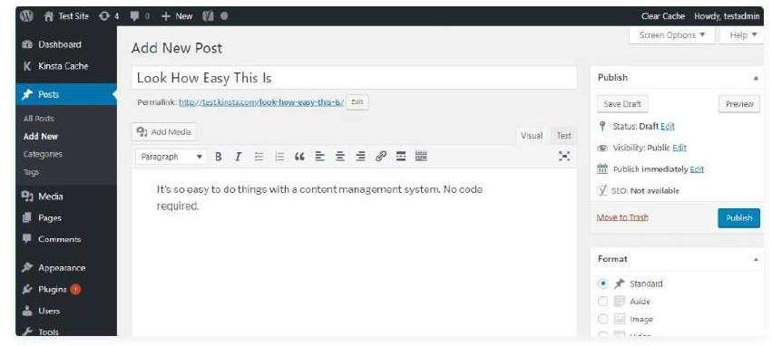

### What Makes up a Content Management System?

On a more technical level, a content management system is made up of two core parts:

* **A content management application (CMA)** – this is the part that allows you to actually add and manage content on your site (like you saw above).
* **A content delivery application (CDA)** – this is the backend, behind-the-scenes process that takes the content you input in the CMA, stores it properly, and makes it visible to your visitors.

Beyond the self-hosted WordPress software, other [popular content management](https://kinsta.com/blog/cms-software/) [systems](https://kinsta.com/blog/cms-software/) include:

* [Joomla](https://kinsta.com/blog/joomla-vs-wordpress/)
* [Drupal](https://kinsta.com/blog/wordpress-vs-drupal/)
* [Magento](https://kinsta.com/magento-market-share/) (for eCommerce stores)
* [Squarespace](https://kinsta.com/blog/squarespace-vs-wordpress/)
* [Wix](https://kinsta.com/wix-market-share/)
* TYPO3

### Drupal:

Drupal is a flexible CMS based on the LAMP stack, with a modular design allowing features to be added and removed by installing and uninstalling modules, and allowing the entire look and feel of the website to be changed by installing and uninstalling themes.

The base Drupal download, known as Drupal Core, contains the PHP scripts needed to run the basic CMS functionality, several optional modules and themes, and many JavaScript, CSS, and image assets.

Many additional modules and themes can be downloaded from the Drupal.org website.

Drupal is open-source software released under the [GNU Public License.](https://www.drupal.org/about/licensing) This means it has inherent benefits--cost, flexibility, freedom, security, and accountability--that are unmatched by proprietary software. For example, Drupal is free to download and anyone can modify and extend the platform. This ensures freedom from vendor "lock in" and it empowers users worldwide to monitor Drupal's underlying code for compliance and security issues and fix them quickly.

### Full of features and highly customizable

* Drupal shines as a CMS. It provides a user interface that allows you to create and publish your content easily.
* The platform accommodates unlimited content types, including text and media content, with highly customizable forms
* It dynamically retrieves, filters, and presents this content with powerful, yet simple-to- use tools.
* There are also intuitive content creation tools and powerful in-place editing tools. Drupal controls access to content and features with its sophisticated user role classification and permissions system.
* Drupal is also a powerful website development platform. Drupal adheres to modern object-oriented programming patterns, PHP best practices, HTML5 and YAML standards.

**Is versatility important?**

* Architected for great mobile experiences. ...
* Great multilingual support. ...
* Platform independent. ...
* Powerful taxonomy and menu structures. ...
* Workflow and content moderation. ...
* Decoupled Drupal for multichannel experiences. ...
* Drupal is different.

### Drupal can also run on other technology stacks:

The operating system can be Windows or Mac OS instead of Linux. The web server can be Nginx or IIS instead of Apache.

The database can be PostgreSQL or SQLite instead of MySQL, or a MySQL-compatible replacement such as MariaDB or Percona.

Other operating systems, web servers, and databases can also be made to work; however, the scripts that the software uses are written in PHP, so that cannot be changed.

### What are the reasons for using Drupal?

When building a website, you have your choice of using one of the many existing CMS packages and hosted services, developing your own CMS, or building the site without using a CMS.

Here are some of the reasons you might choose to use Drupal:

* + Building a small, simple site with static HTML pages is not difficult, and you can get a simple site up very quickly.
  + Some CMS software is special-purpose; for instance, there are packages and hosted services that you can use to build a blog or a club membership website.
  + Building your own CMS-type software can seem attractive. However, using a general-purpose CMS like Drupal as a starting point is usually a better idea, because the basic CMS functionality (such as user accounts and content management).
  + Some CMS software packages are expensive to purchase a license for. Some are free or have a free version, but have restrictive licenses that do not allow you to make modifications and extensions.
  + It can be used for almost any type of business. Drupal is a great choice whether you have an agency, an airline company, a charity, a store and almost anything else!
  + Drupal SEO options are ones of the best on the market Each item in Drupal development can be given a custom URL that is referred to as ‘URL alias’. Also, each of these URLs can be adjusted to the content type e.g. blog post, page or description as well as the keywords, date & time, or any other information you want to link to it. In comparison, WordPress limits you to one type of URL for all content and Joomla is lacking the control and customization of the URL’s parameters.
  + Extensive content optimization functionality. CCK or the content construction kit is one of the Drupal modules that allows you to create custom content types. Meaning, you can create your specific view of news threads, blog posts, photo albums, tutorials and a lot more. This Drupal module is special because other content management systems require you to write your own code if you want to change the content default look. Views attach, an add-on to ensure Drupal SEO compliance, allows you to create content silos using its point-and- click user interface.
  + Great content categorization feature. Another great feature Drupal has is its Taxonomy module which is actually a categorization system. One of the many Drupal modules, Taxonomy allows you to organize and tag content according to important keywords. Just follow basic SEO principles and make sure any content is never more than three clicks away.
  + Seamless Google Analytics integration Yep, it offers a free Google Analytics module for your Drupal website. This module allows you to manage the analytics code depending on your preferences. For instance, you might not be interested in tracking certain pages or you don’t want to be confused by company employees browsing your website.
  + Drupal-built websites are easy to edit Drupal offers an amazing built-in version control that a) automatically saves new versions of your website; b) allows you to restore an old version of the page anytime you want. It’s great

for various types of A/B testing to see what content works better, which design is more engaging and to pretty much fix the mistakes accidentally made during the updates.

* + Drupal community support is awesome Drupal has a passionate and active community that is here for you. Drupal.org has more than 650,000 registered user accounts and around 2,000 developer accounts. You can find a community-contributed module for every taste as well as ask them anything – even such a simple question as “how to install drupal”, no one will judge you:)
  + Multiple user roles. Originally, Drupal was designed for community-based websites. Because of this, since the very beginning, it had rather extensive opportunities for various user roles and, as a result, extensive access control functionality. In other words, there is no limit to the imagination when it comes to granting user roles. You’ll most likely have an ‘unknown visitor’, ‘registered user’, ‘editor’, ‘admin’, ‘moderator’ and so on.
  + It doesn’t have any hidden charges Drupal development services are free of additional charges. Meaning, if you hire a Drupal agency you are paying for the developer’s time and not for using the platform. All Drupal modules including plug-ins, add-ons and widgets are completely free.
  + Extensive integration options Drupal software development allows you to include various integrations with applications and services. It means that you can easily add any Drupal-developed product into your existing ecosystem without experiencing much of a change. Like, the data collected from your new website can be stored directly in your CRM or ERP systems.

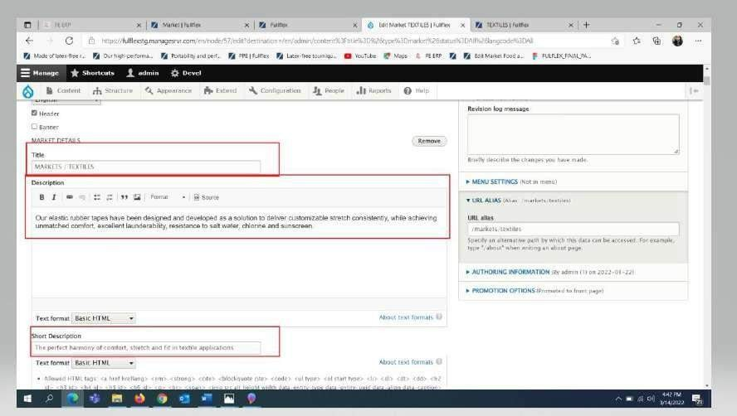

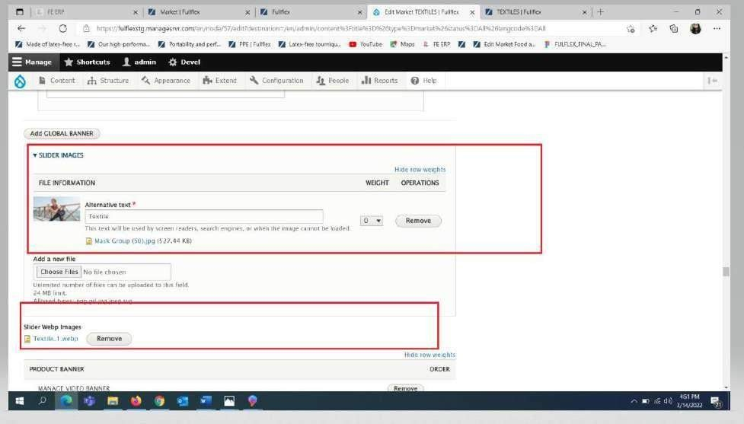

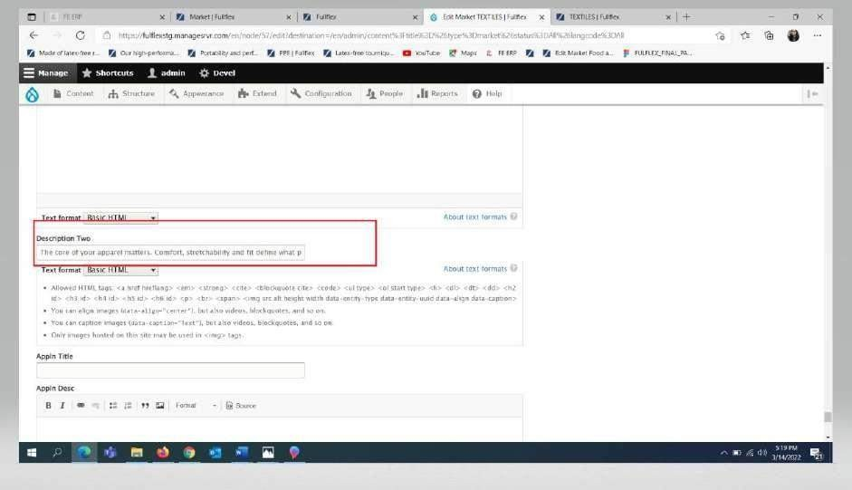

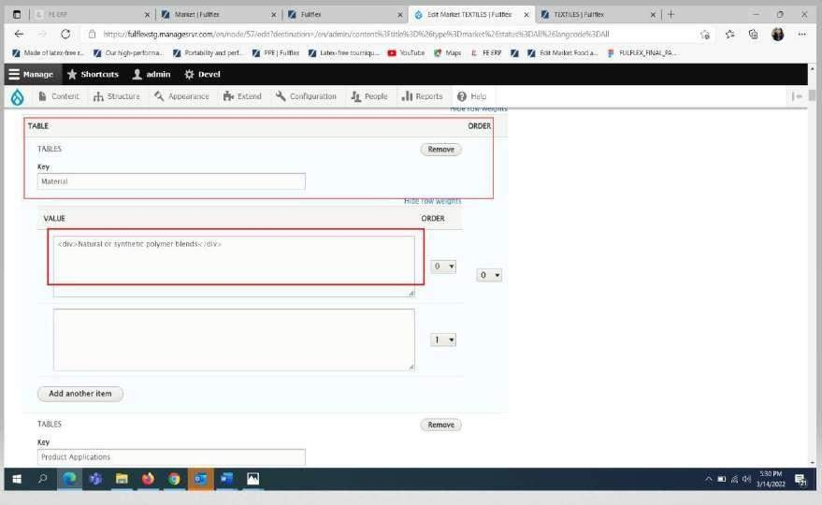

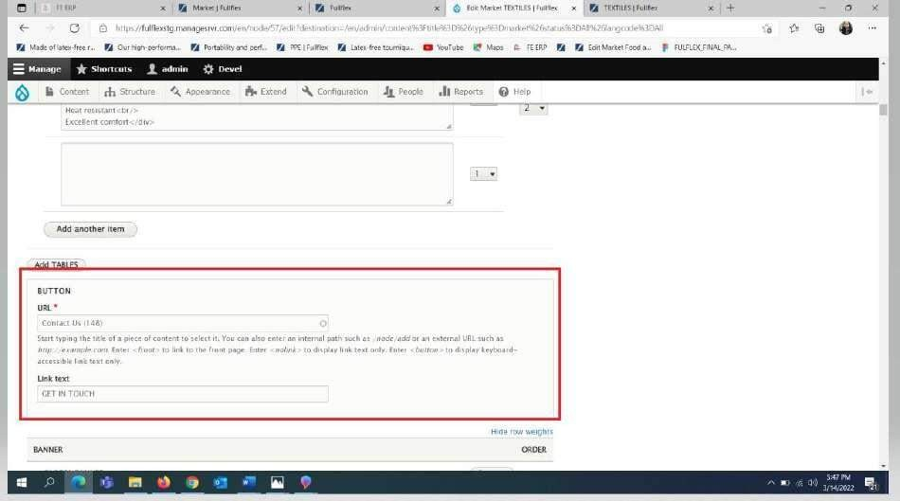

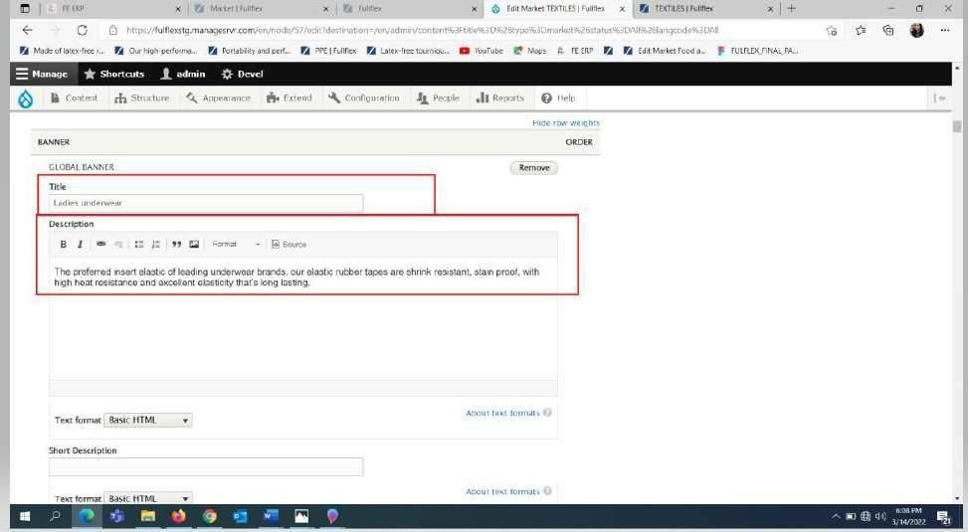

### PHP 7.4

PHP tutorial for beginners and professionals provides in-depth knowledge of PHP scripting language. Our PHP tutorial will help you to learn PHP scripting language easily.

This PHP tutorial covers all the topics of PHP such as introduction, control statements, functions, array, string, file handling, form handling, regular expression, date and time, object-oriented programming in PHP, math, PHP MySQL, PHP with Ajax, PHP with jQuery and PHP with XML.

PHP is an open-source, interpreted, and object-oriented scripting language that can be executed at the server-side. PHP is well suited for web development. Therefore, it is used to develop web applications (an application that executes on the server and generates the dynamic page).

PHP was created by **Rasmus Lerdorf in 1994** but appeared in the market in 1995.

**PHP 7.4.0** is the latest version of PHP, which was released on **28 November**. Some important points need to be noticed about PHP are as followed.

* PHP stands for Hypertext Preprocessor.
* PHP is an interpreted language, i.e., there is no need for compilation.
* PHP is faster than other scripting languages, for example, ASP and JSP.
* PHP is a server-side scripting language, which is used to manage the dynamic content of the website.
* PHP can be embedded into HTML.
* PHP is an object-oriented language.
* PHP is an open-source scripting language.
* PHP is simple and easy to learn language.

# What Does PHP 7.4 Mean for You?

PHP continues to evolve with the newest PHP 7.4 update full of new features. Like we have seen in previous PHP 7 releases, performance and speed keep improving. One of the most exciting new features is **preloading**. It helps speed up script execution and introduces the ability to have faster and cleaner code, thanks to the simplification of common lines of code.

The good people responsible for PHP have heard their audience’s comments and requests and answered them completely. They have since been continuously changing code to be more intuitive and easier to switch between programming languages.

PHP is used in over 78.9% of all websites. According to [**W3techs**](https://w3techs.com/technologies/details/pl-php), the most popular sites using PHP are Wikipedia, Pinterest, and Facebook, to name a few.

If we specifically look at WordPress sites running PHP, comparing PHP 5 and 7, we can see a double speed increase. WordPress-powered websites definitely gain the most by using the latest PHP version. Hostinger users can supercharge their WordPress sites with just a click of

a button.

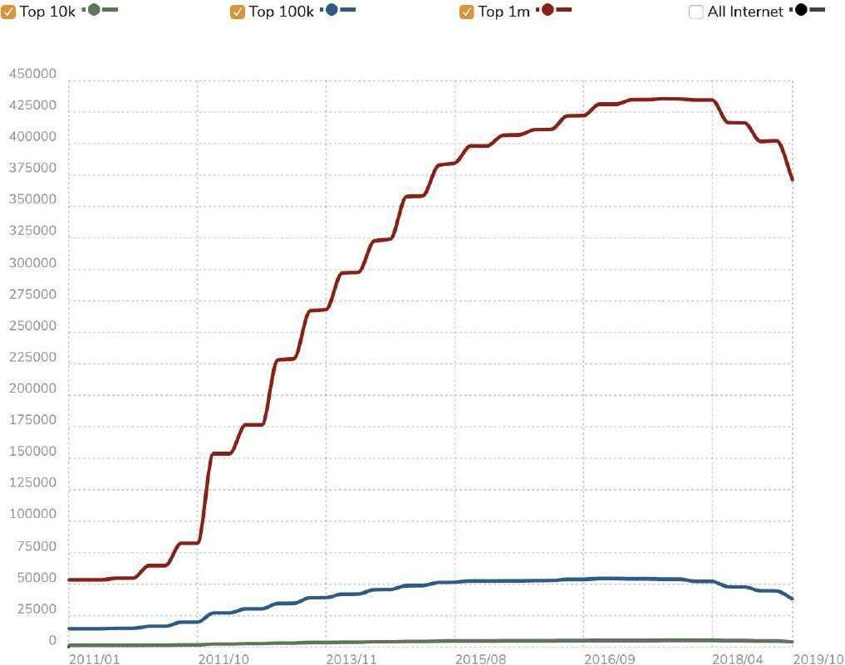

See all these cool figures? This graph contains information about websites actively using PHP. Are [39,191,714](https://trends.builtwith.com/websitelist/PHP) live websites enough to grab your attention? That’s how many are using PHP right now. Plus PHP 7.4 is already testing better than PHP 7.3 with improved performance and other quality of life improvements.

The graph below shows the overall [benchmark test](https://www.phoronix.com/scan.php?page=article&item=php-74-benchmarks&num=1) on new and old versions of PHP. Some of the criteria tested were ease of use, speed, and performance.

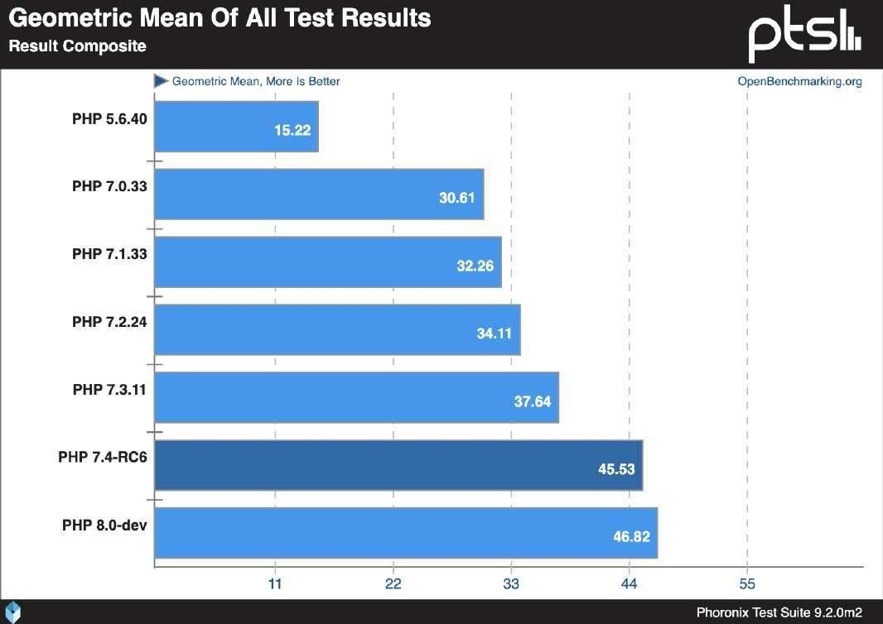

# What’s New in PHP 7.4?

Since 2016, PHP7 has been releasing annual updates without fail. Each year they deliver new features, additions, and the possibility to write cleaner code that makes the language more reliable and user-friendly for those who run it on their websites.

Let’s dig in and take a closer look at some of the changes that were made in PHP 7.4. For a full list check out the changelog [here.](https://www.php.net/manual/en/migration74.php)

### DATABASE:

**MYSQL:**

MySQL is a fast, easy-to-use RDBMS being used for many small and big businesses. MySQL is developed, marketed and supported by MySQL AB, which is a Swedish company. MySQL is becoming so popular because of many good reasons −

* MySQL is released under an open-source license. So you have nothing to pay to use it.
* MySQL is a very powerful program in its own right. It handles a large subset of the functionality of the most expensive and powerful database packages.
* MySQL uses a standard form of the well-known SQL data language.
* MySQL works on many operating systems and with many languages including PHP, PERL, C, C++, JAVA, etc.
* MySQL works very quickly and works well even with large data sets.
* MySQL is very friendly to PHP, the most appreciated language for web development.
* MySQL supports large databases, up to 50 million rows or more in a table. The default file size limit for a table is 4GB, but you can increase this (if your operating system can handle it) to a theoretical limit of 8 million terabytes (TB).
* MySQL is customizable. The open-source GPL license allows programmers to modify the MySQL software to fit their own specific environments.

# Features of My Sql:

### Open-Source

MySQL is open-source, which means this software can be downloaded, used and modified by anyone. It is free-to-use and easy-to-understand. The source code of MySQL can be studied, and changed based on the requirements.

### Quick and Reliable

MySQL stores data efficiently in the memory ensuring that data is consistent, and not redundant. Hence, data access and manipulation using MySQL is quick.

### Scalable

Scalability refers to the ability of systems to work easily with small amounts of data, large amounts of data, clusters of machines, and so on. MySQL server was developed to work with large databases.

### Data Types

It contains multiple data types such as unsigned integers, signed integers, float (FLOAT), double (DOUBLE), character (CHAR), variable character (VARCHAR), text, blob, date, time, datetime, timestamp, year, and so on.

### Character Sets

It supports different character sets, and this includes latin1 (cp1252 character encoding), German, Ujis, other Unicode character sets and so on.

### Secure

It provides a secure interface since it has a password system which is flexible, and ensures that it is verified based on the host before accessing the database. The password is encrypted while connecting to the server.

### Support for large databases

It comes with support for large databases, which could contain about 40 to 50 million records, 150,000 to 200,000 tables and up to 5,000,000,000 rows.

### Client and Utility Programs

MySQL server also comes with many client and utility programs. This includes Command

line programs such as ‘mysqladmin’ and graphical programs such as ‘MySQL Workbench’. MySQL client programs are written in a variety of languages. Client library (code encapsulated in a module) can be written in C or C++ and would be available for clients that have C bindings.

### MariaDB:

MariaDB is a fork of the MySQL relational database management system. The original developers of MySQL created MariaDB after concerns raised by Oracle's acquisition of MySQL. This tutorial will provide a quick introduction to MariaDB, and aid you in achieving a high level of comfort with MariaDB programming and administration.

MariaDB Server is one of the most popular open-source relational databases. It’s made by the original developers of MySQL and guaranteed to stay open source. It is part of most cloud offerings and the default in most Linux distributions.

It is built upon the values of performance, stability, and openness, and MariaDB Foundation ensures contributions will be accepted on technical merit. Recent new functionality includes advanced clustering with Galera Cluster 4, compatibility features with Oracle Database and Temporal Data Tables, allowing one to query the data as it stood at any point in the past.

MariaDB takes a fundamentally different database approach to fit today’s modern world. Our pluggable, purpose-built storage engines support workloads that previously required a variety of specialized databases. Organizations can now depend on a single complete database for all their needs, whether on commodity hardware or their cloud of choice. Deployed in minutes for transactional, analytical or hybrid use cases, MariaDB delivers unmatched operational agility without sacrificing key enterprise features, including real ACID compliance and full SQL.

Experience the same benefits as customers like Deutsche Bank, DBS Bank, Nasdaq, Red Hat, ServiceNow, Verizon and Walgreens – industry leaders who trust MariaDB to deliver unmatched operational agility, provide enterprise reliability and drive collaborative innovation. Real business relies on MariaDB**.**

The development of MariaDB was led by Michael "Monty" Widenius, who was also the lead developer on MySQL and a founder of MySQL AB, a vendor that Sun bought in 2008. After leaving Sun in early 2009, he and several colleagues began work on a MySQL storage engine that soon morphed into MariaDB, which is named after Widenius's youngest daughter. He also formed a new company that merged with a database consulting business to create what eventually became known as MariaDB Corp.

The first release of MariaDB, known as version 5.1, became available for production uses in early 2010. Versions 5.2, 5.3 and 5.5 followed, and then MariaDB 10.0 was released in 2014. It represented a change in the database's classification scheme, as earlier release numbers were patterned after MySQL ones.

MariaDB 10.1 and 10.2 came after that in 2015 and 2017, respectively. The 10.2 version, which was up to a 10.2.12 release as of January 2018, employs InnoDB as the default storage engine, and new features include a JSON data type designed to boost ties with MySQL on JSON. Next in line for release is MariaDB 10.3, which became available in alpha and beta versions in 2017.

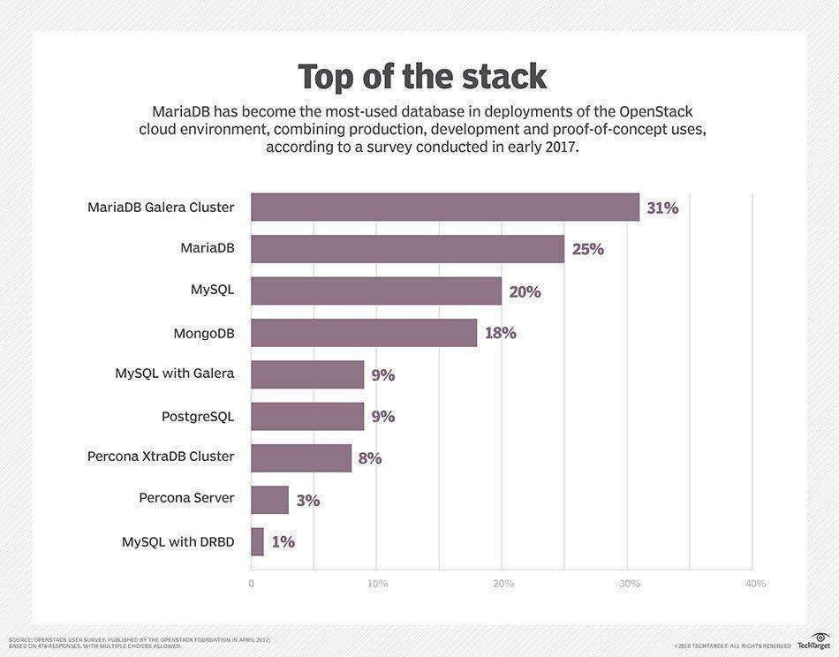

### Key Features of MariaDB

The important features of MariaDB are −

* + All of MariaDB is under GPL, LGPL, or BSD.
  + MariaDB includes a wide selection of storage engines, including high
  + performance storage engines, for working with other RDBMS data sources.
  + MariaDB uses a standard and popular querying language.
  + MariaDB runs on a number of operating systems and supports a wide variety of programming languages.
  + MariaDB offers support for PHP, one of the most popular web development languages.
  + MariaDB offers Galera cluster technology.
  + MariaDB also offers many operations and commands unavailable in MySQL, and eliminates/replaces features impacting performance negatively.InnoDB is a general purpose storage engine known for balancing high reliability and high performance.
  + Once a more popular choice than InnoDB, XtraDB was designed as a drop-in storage engine for MariaDB. This was back in versions prior to 10.1. Since

10.2 of MariaDB, InnoDB has become default storage engine for Maria.

* + My Rocks is a piece of open -source software that was developed by the database engineering team at Facebook and is still maintained over there.
  + Galera Cluster is “a true Multi-Master Cluster” based around synchronous replication. Its main aim is to provide high up-time, prevent loss of data and be scalable for growth. Synchronous replication means that the slave doesn’t lag and there’s no data lost if the node crashes.
  + Sequence engines let you create ascending or descending sequences of numbers with a given starting value, ending value, and increment value.

### Web server:

Web servers are software or hardware (or both together) that stores and delivers content to a web browser at a basic level. The servers communicate with browsers using Hypertext Transfer Protocol (HTTP).

Web servers can also support SMTP (Simple Mail Transfer Protocol) and FTP (File Transfer Protocol).

Web servers are also used for hosting websites and data for web applications. They can host single websites and multiple websites using virtualization.

Years ago, when Web servers were first prototyped, they served simple HTML documents and images. Today, as we shall go into later in this tutorial, they are frequently used for much more.

The second important advance, and the one that makes e-commerce possible, was the introduction of Hyper Text Transmission Protocol, Secure (HTTPS). This protocol allows secure communication to go on between the browser and Web server.

A **web server** is [computer](https://en.wikipedia.org/wiki/Computer) [software](https://en.wikipedia.org/wiki/Software) and underlying [hardware](https://en.wikipedia.org/wiki/Computer_hardware) that accepts requests via [HTTP](https://en.wikipedia.org/wiki/Hypertext_Transfer_Protocol) (the [network protocol](https://en.wikipedia.org/wiki/Network_protocol) created to distribute [web content](https://en.wikipedia.org/wiki/Web_content)) or its secure variant [HTTPS](https://en.wikipedia.org/wiki/HTTPS). A user agent, commonly a [web browser](https://en.wikipedia.org/wiki/Web_browser) or [web crawler,](https://en.wikipedia.org/wiki/Web_crawler) initiates

communication by making a request for a [web page](https://en.wikipedia.org/wiki/Web_page) or other [resource](https://en.wikipedia.org/wiki/Web_Resource) using HTTP, and

the [server](https://en.wikipedia.org/wiki/Server_(computing)) responds with the content of that resource or an [error message.](https://en.wikipedia.org/wiki/List_of_HTTP_status_codes) A web server can also accept and store resources sent from the user agent if configured to do so[.[](https://en.wikipedia.org/wiki/Web_server#cite_note-web-server-technology-1)

The hardware used to run a web server can vary according to the volume of requests that it needs to handle. At the low end of the range are [embedded systems,](https://en.wikipedia.org/wiki/Embedded_system) such as a [router](https://en.wikipedia.org/wiki/Router_(computing)) that runs a small web server as its configuration interface. A high-traffic [Internet](https://en.wikipedia.org/wiki/Internet) [website](https://en.wikipedia.org/wiki/Website) might handle requests with hundreds of servers that run on racks of high-speed computers.

### History

This is a very brief history of web server programs, so some information necessarily overlaps with the histories of the web browsers, the World Wide Web and the Internet; therefore, for the sake of the clearness and understandability, some key historical information below reported may be similar to that found also in one or more of the above-mentioned history articles.

**Characteristics of Web Server**

[Web server](https://digitalthinkerhelp.com/what-is-web-server-definition-types-examples-working-uses/) is a combination of software and hardware that uses HTTP (Hypertext Transfer Protocol) as well as other protocols for getting responds to each client requests made over the WWW (World Wide Web).

### Features of Web Server

Here, we will explain the features of web server and characteristics**;** like as

* [Web Server](https://digitalthinkerhelp.com/what-is-web-server-definition-types-examples-working-uses/) can support enlarge data storage support, so it is capable to make multiple websites.
* Easy to configure log file set up, enabling where to hold all log files. (Log files help to analyses web traffic and more)
* It helps to control bandwidth to regulate network traffic, so due to this it can avoid the down time while flowing high volume web traffic.
* Easy to make FTP websites, because it helps to move enlarge files from one site to other site.
* Easy to set up website configuration and directory security
* Easy to make virtual directories, and then help to map them along with physical directories.
* Easy to set up of custom error pages [configuration](https://en.wikipedia.org/wiki/Configuration) that means it helps to view user friendly error messages on your website, when your website is getting any issues like as 404 Error will be displayed if web pages do not present.
* Can be specified default documents for example if any file has not specify with its name then default documents will be displayed.
* It is enabled with Server-side web scripting so it allows user to make dynamic websites. Few [types of server-](https://digitalthinkerhelp.com/what-is-server-in-networking-types-examples-functions-and-uses/) side scripting languages are PHP, ASP, Ruby, Perl,Python, and more.

### NGINX:

Nginx is open-source software for web serving, reverse proxying, caching, load balancing, media streaming, and more. It started out as a web server designed for maximum performance and stability. In addition to its HTTP server capabilities, NGINX can also

function as a proxy server for email (IMAP, POP3, and SMTP) and a reverse proxy and load balancer for HTTP, TCP, and UDP servers.

The goal behind NGINX was to create the fastest web server around, and maintaining that excellence is still a central goal of the project. NGINX consistently beats Apache and other servers in benchmarks measuring web server performance.

Though NGINX became famous as the fastest web server, the scalable underlying architecture has proved ideal for [many web tasks beyond serving content](https://www.nginx.com/products/nginx/). Because it can handle a high volume of connections, NGINX is commonly used as a reverse proxy and [load](https://www.nginx.com/blog/five-reasons-use-software-load-balancer/) [balancer](https://www.nginx.com/blog/five-reasons-use-software-load-balancer/) to manage incoming traffic and distribute it to slower upstream servers – anything from legacy database servers to microservices.

NGINX is a well- known open-source project originally written by Igor Sysoev, a Russian engineer. Igor started the project in 2002 and made it public in 2004. Since that time NGINX has become a de-facto standard for high-performance, scalable websites. Tens of millions

of [active websites](https://news.netcraft.com/archives/category/web-server-survey/) use NGINX, including [1 million busiest websites](https://w3techs.com/technologies/cross/web_server/ranking) in the world. Companies like Airbnb, Box, Dropbox, Netflix, Tumblr, WordPress.com, and many others deploy NGINX for scalability and performance reasons.

### Why use NGINX?

* + NGINX provides various services such as reverse proxy, load balancer, and rate limit network services.
  + Reverse proxying is useful if we have multiple web services listening on various ports and we need a single public endpoint to reroute requests internally. This would allow us to host multiple domain names on port 80 while using a combination of different NodeJs, Go and java to power separate web services behind the scenes
  + Nginx can handle the logging, blacklisting, load balancing and serving static files while the web services focus on what they need to do.
  + The configuration of Nginx is easier than Apache httpd. Nginx was designed for high concurrency and it is very fast.

### Features of NGINX

Some features of Nginx are as follows:

* Reverse proxy with caching
* IPV6
* Load Balancing
* Web Sockets
* Handling of static files, index files, and auto-indexing
* Fast CGI support with caching
* URL rewriting and redirection

### What Can NGINX and NGINX Plus Do for You?

NGINX Plus and NGINX are the best-in-class web server and application delivery solutions used by high-traffic websites such as Dropbox, Netflix, and Zynga. More than [400](https://news.netcraft.com/archives/category/web-server-survey/)

[million websites](https://news.netcraft.com/archives/category/web-server-survey/) worldwide rely on NGINX Plus and NGINX Open Source to deliver their content quickly, reliably, and securely.

* As a software-only all-in-one load balancer, web server, API gateway, and reverse proxy that is designed for cloud-native architectures, NGINX helps you accelerate your IT infrastructure and application modernization efforts. NGINX Plus delivers enterprise-grade capabilities that provide robust reliability and security.
* NGINX is a multifunction tool. With NGINX, you can use the same tool as your load balancer, reverse proxy, content cache, and web server, minimizing the amount of tooling and configuration your organization needs to maintain. NGINX

offers [documentation](https://docs.nginx.com/nginx/) and a [wide array of eBooks, webinars, and videos](https://www.nginx.com/resources) to get you on your feet. NGINX Plus includes [rapid-response customer support](https://www.nginx.com/support/), so you can easily get help diagnosing any part of your stack that uses NGINX or NGINX Plus.

* NGINX keeps evolving. For the past decade NGINX has been at the forefront of development of the modern Web, and has helped lead the way on everything from HTTP/2 to microservices support. As development and delivery of web applications continue to evolve, NGINX Plus keeps adding features to enable flawless application delivery, from support for configuration using an implementation of [JavaScript](https://www.nginx.com/blog/introduction-nginscript/) [customized for NGINX,](https://www.nginx.com/blog/introduction-nginscript/) to support for [dynamic modules.](https://www.nginx.com/blog/nginx-plus-r11-released/#r11-dynamic-modules) Using NGINX Plus ensures you’ll stay at the cutting edge of web performance.

### Cloud Services:

Cloud services are infrastructure, platforms, or software that are hosted by third-party providers and made available to users through the internet.

Cloud services facilitate the flow of user data from front-end clients (e.g., users’ servers, tablets, desktops, laptops—anything on the users’ ends), through the internet, to the provider’s systems, and back.

Cloud services promote the building of cloud-native applications and the flexibility of working in the cloud. Users can access cloud services with nothing more than a computer, operating system, and internet connectivity.

When supplying users with a cloud infrastructure, cloud services providers detach computing capabilities from hardware components, such as separating:

* Processing power from central processing units (CPUs)
* Active memory from random access memory (RAM) chips
* Graphics processing from the graphics processing units (GPUs)
* Data storage availability from datacenters or hard drives

### Features of cloud services:

**Resource Pooling** means that the Cloud provider pulled the computing resources to provide services to multiple customers with the help of a multi-tenant model.

**On-demand self service** It is one of the important and valuable features of Cloud Computing as the user can continuously monitor the server uptime, capabilities, and allotted network storage. With this feature, the user can also monitor the computing capabilities.

**Easy Maintenance** The servers are easily maintained and the downtime is very low and even in some cases, there is no downtime. Cloud Computing comes up with an update every time by gradually making it better.

**Large Network Access** The user can access the data of the cloud or upload the data to the cloud from anywhere just with the help of a device and an internet connection.

**Availability** The capabilities of the Cloud can be modified as per the use and can be extended a lot. It analyzes the storage usage and allows the user to buy extra Cloud storage if needed for a very small amount.

**Automatic System** Cloud computing automatically analyzes the data needed and supports a metering capability at some level of services. We can monitor, control, and report the usage. It will provide transparency for the host as well as the customer.

**Economical** is the one-time investment as the company (host) has to buy the storage and a small part of it can be provided to the many companies which save the host from monthly or yearly costs.

**Cloud Security**, is one of the best features of cloud computing. It creates a snapshot of the data stored so that the data may not get lost even if one of the servers gets damaged.

Pay as you go, in cloud computing, the user has to pay only for the service or the space they have utilized. There is no hidden or extra charge which is to be paid. This service is economical and most of the time some space is allotted for free.

**2.3 Technology used in project**

|  |  |  |
| --- | --- | --- |
| **Number** | **Description** | **Type** |
| 1 | Operating System | Windows XP / Windows |
| 2 | Front End: | HTML, CSS & jQuery |
| 3 | Back End: | CMS Drupal 9.0, PHP 7.4 & jQuery |
| 4 | Database Used: | Mysql5 & MariaDB 10.3.32 |
| 5 | Web Server: | Nginx, PHP-FPM, PHP 7+ |
| 6 | Cloud Services: | AWS SES, AWS CloudFront CDN, AWS S3 |

# Chapter 3 Backend design

### Drupal:

Drupal is a flexible CMS based on the LAMP stack, with a modular design allowing features to be added and removed by installing and uninstalling modules, and allowing the entire look and feel of the website to be changed by installing and uninstalling themes.

The base Drupal download, known as Drupal Core, contains the PHP scripts needed to run the basic CMS functionality, several optional modules and themes, and many JavaScript, CSS, and image assets.

Many additional modules and themes can be downloaded from the Drupal.org website. Drupal is open-osource software released under the [GNU Public License](https://www.drupal.org/about/licensing). This means it has inherent benefits--cost, flexibility, freedom, security, and accountability--that are unmatched by proprietary software. For example, Drupal is free to download and anyone can modify and extend the platform. This ensures freedom from vendor "lock in" and it empowers users worldwide to monitor Drupal's underlying code for compliance and security issues and fix them quickly.

Drupal is a free, open-source content management system (CMS) with a large, supportive community. It's used by millions of people and organizations around the globe to build and maintain their websites. You probably use Drupal every day without knowing it, as many top businesses and government organizations use Drupal, like the Government of Australia, Red Cross, Harvard, The Economist, BBC, NBC News, Whole Foods, Cisco, Twitter, and many, many more.

**Why Use Drupal?**

Drupal is perfect for both the default features and the customized ones. It provides you with the most common functionalities any website needs but is also flexible enough to allow you to create a unique, customized experience. Here are some of Drupal's key benefits:

* **Flexible**, easy-to-use content authoring tools
* **"Create once, publish anywhere"** approach to content management
* Highly **customizable** features
* Powerful **API-first** architecture
* Numerous, **freely available modules** (add-on functionality)
* Constant **innovation** powered by a massive, engaged community

To accomplish that, Drupal provides numerous out-of-the-box features. The more you can learn about how Drupal works, the more you'll be able to leverage its full range of features:

* **WYSIWYG** authoring and editing tool that allows editors and admins to easily search for, draft, edit, preview, archive, publish, and update content
* **Layout Builder** - A powerful no-code solution to easily build engaging pages with templated layouts and drag-and-drop UI for placing content on the page
* **Customizable workflows** and approvals, as well as revisions, so that you can track every content update and revert to a previous version
* **Media** supports local audio, video, images, files, as well as remote content from YouTube, Vimeo, Twitter, etc.
* **Media Library** allows users to add existing media assets to a site as well as upload new items directly into the library
* Performance-optimized **caching mechanisms**
* **Theme system** enables you to create a completely custom, responsive front-end according to brand guidelines and using your framework of choice
* Recommended add-on (contribute) **modules**
* Easy-to-use **form builder** to create anything from a simple contact form or survey to complex, multi-step application forms
* **Schedule** when your content is published in advance
* Customizable, **user-friendly URLs** and configurable metatags for every piece of content
* Robust **search experience** and integration with enterprise-grade search engines (Elasticsearch or floor)
* **Migrate system** allows you to feed data into Drupal
* **Multilingual** content & user interface
* **Accessibility** compliance (WCAG AA)

### Drupal can also run other technology stack:

The operating system can be Windows or Mac OS instead of Linux. The web server can be Nginx or IIS instead of Apache.

The database can be PostgreSQL or SQLite instead of MySQL, or a MySQL-compatible replacement such as MariaDB or Persona.

Other operating systems, web servers, and databases can also be made to work; however, the scripts that the software uses are written in PHP, so that cannot be changed.

What are the reasons for using Drupal?

When building a website, you have your choice of using one of the many existing CMS packages and hosted services, developing your own CMS, or building the site without using a CMS.

Here are some of the reasons you might choose to use Drupal:

* Building a small, simple site with static HTML pages is not difficult, and you can get a simple site up very quickly.
* Some CMS software is special-purpose; for instance, there are packages and hosted services that you can use to build a blog or a club membership website.
* Building your own CMS-type software can seem attractive. However, using a general- purpose CMS like Drupal as a starting point is usually a better idea, because the basic CMS functionality (such as user accounts and content management).
* Some CMS software packages are expensive to purchase a license for. Some are free or have a free version, but have restrictive licenses that do not allow you to make modifications and extensions.

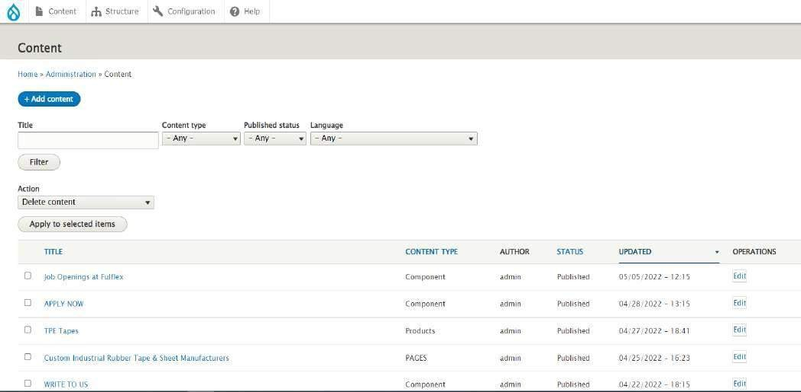

### Applications:

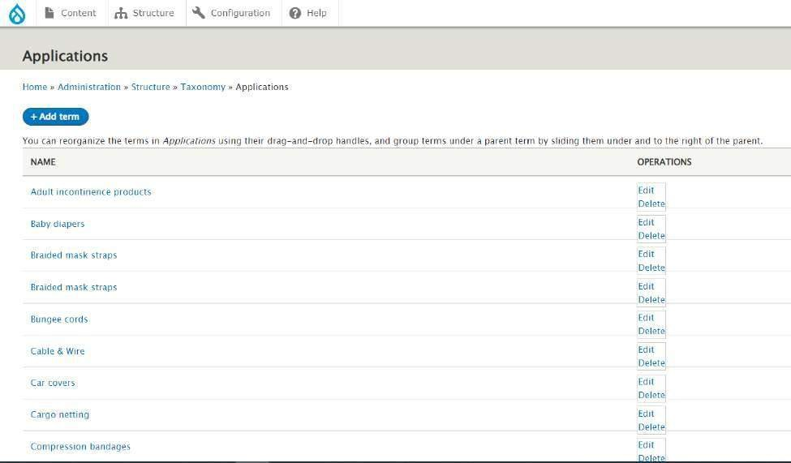

**Languages:**

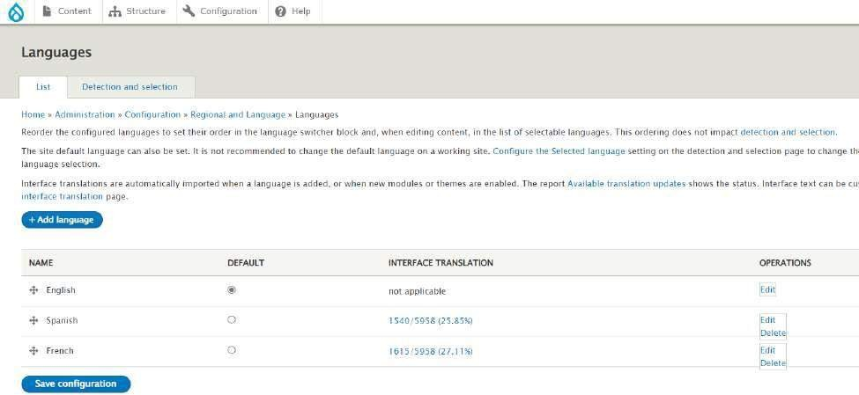

**Administrations:**

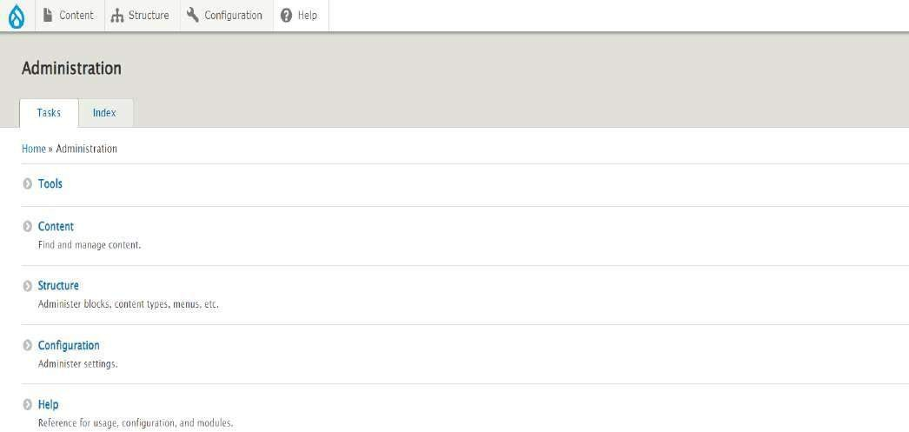

# Chapter 4 Front End Design

### PROD WEBSITE: HOME PAGE:

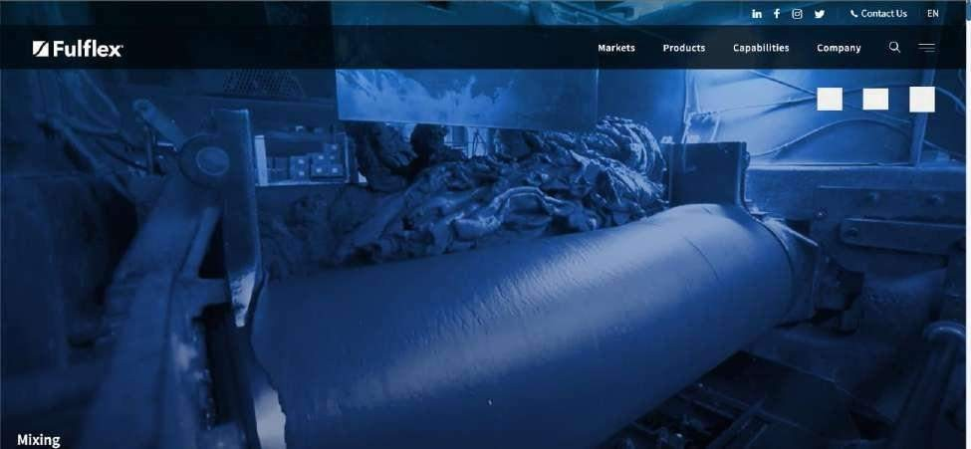

**MARKET PAGE:**

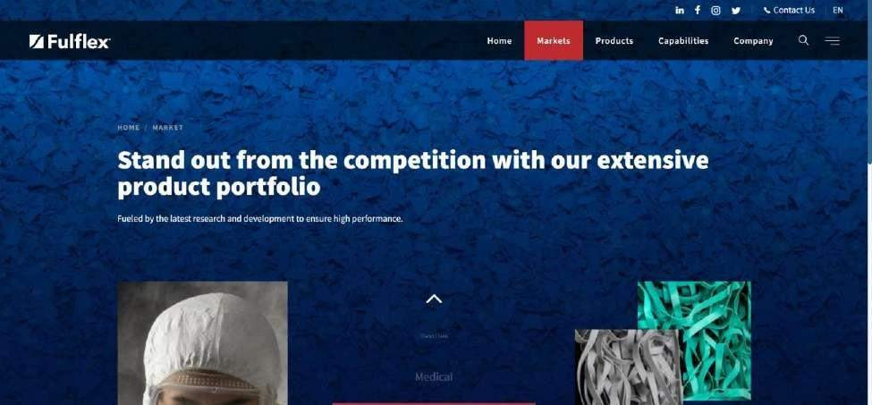

### PRODUCT PAGE:

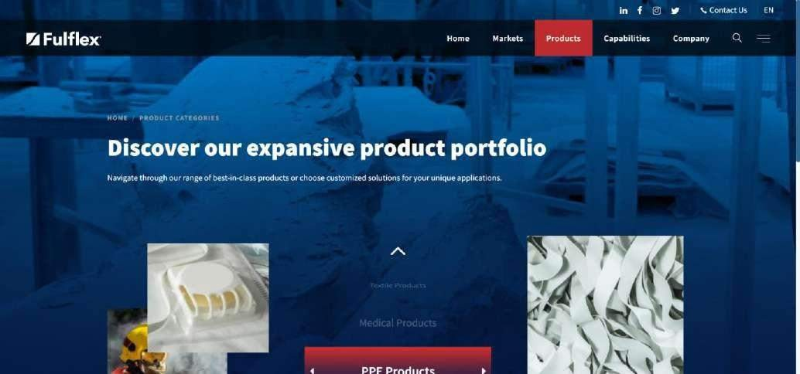

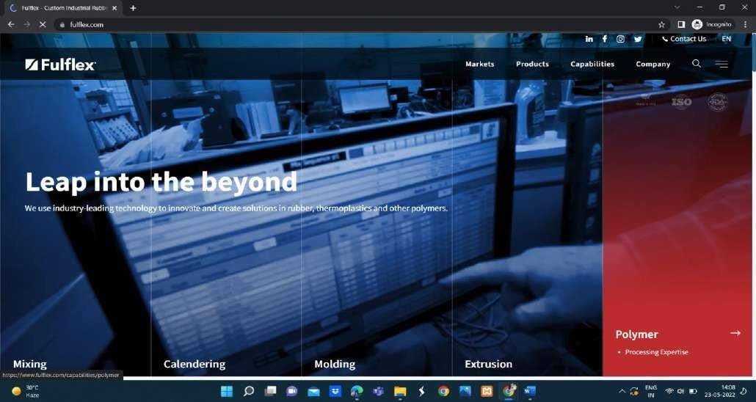

**Key Facts**

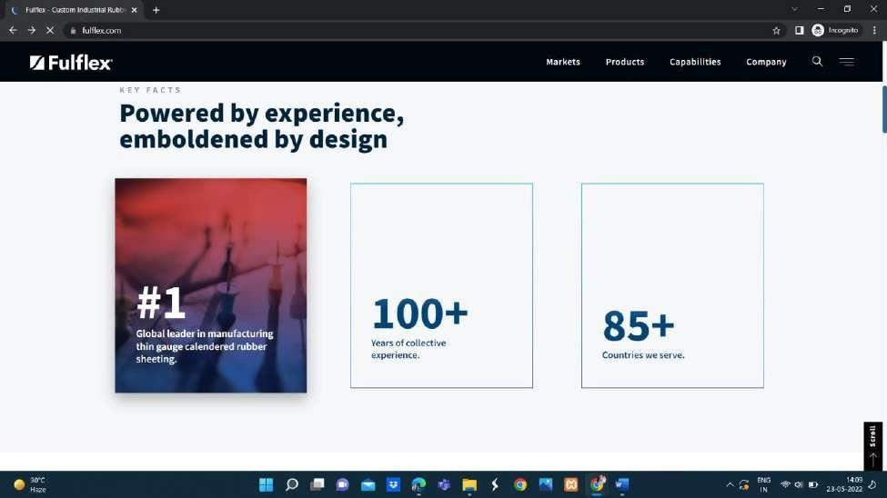

### Innovations

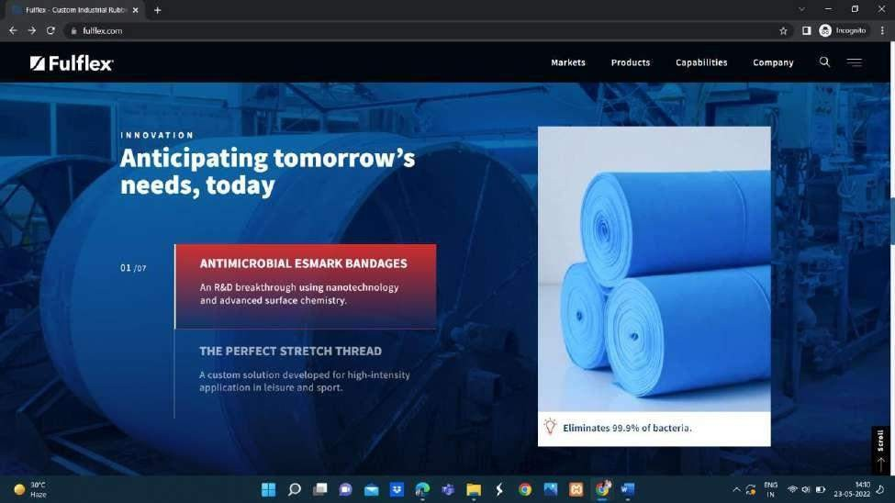

**Our Leadership Edge**

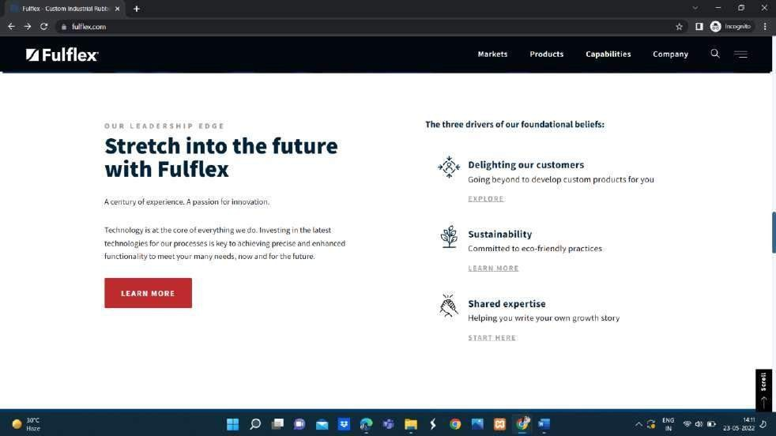

### Collaborate with us

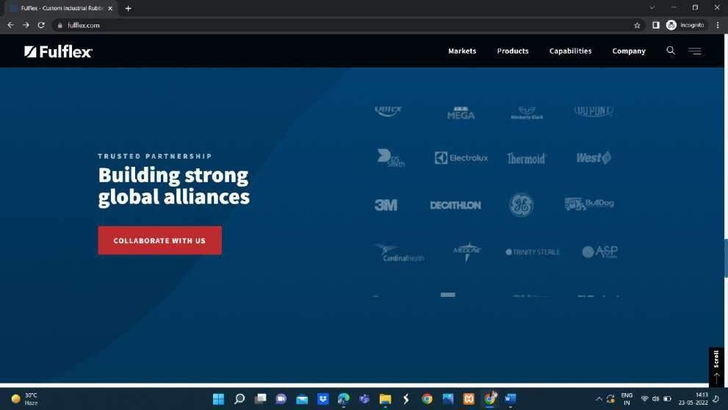

**Diversity and Inclusion**

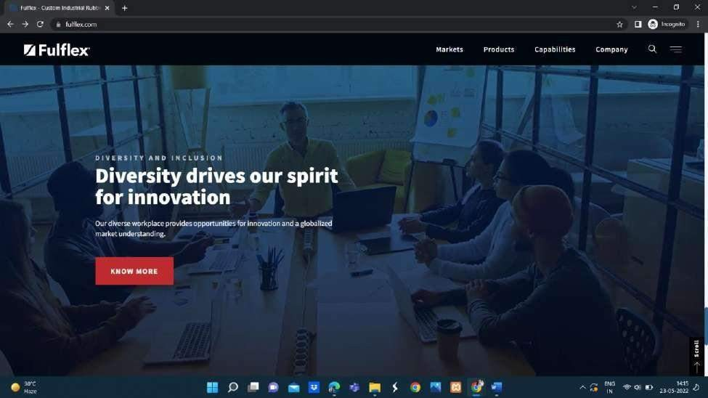

### CAPABILITIES:



**Extrusion**

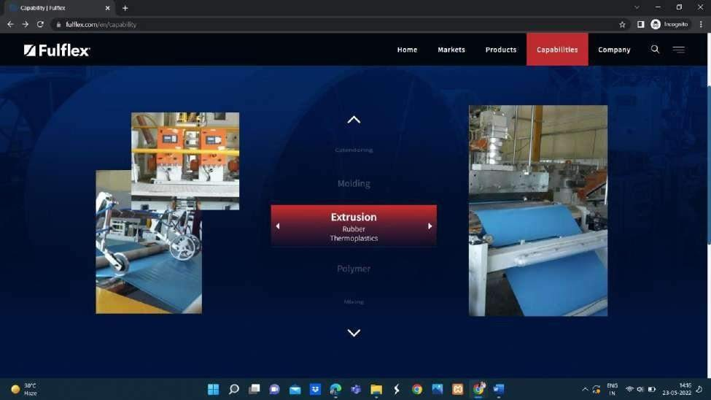

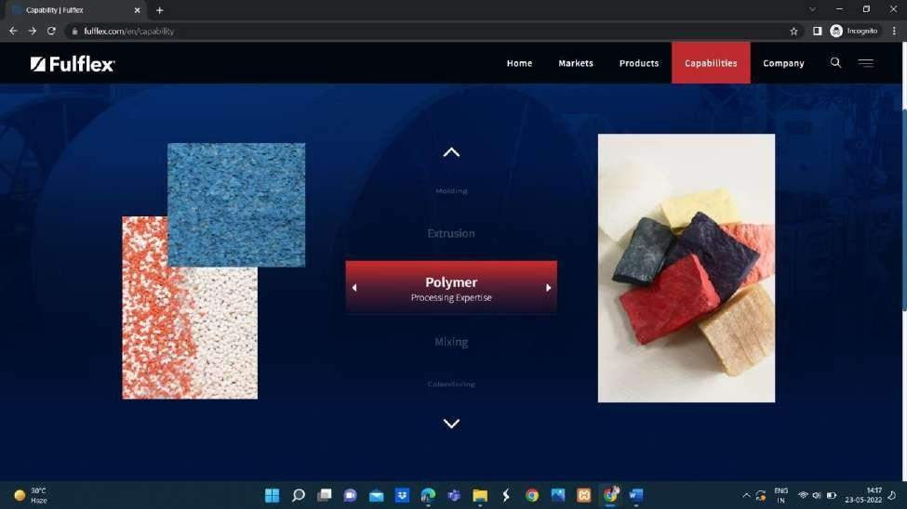

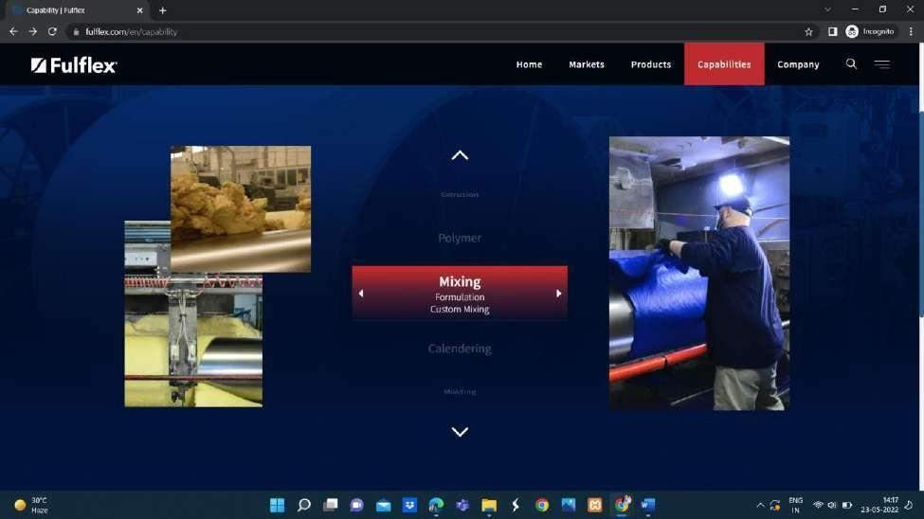

### Detailed page of capabilities

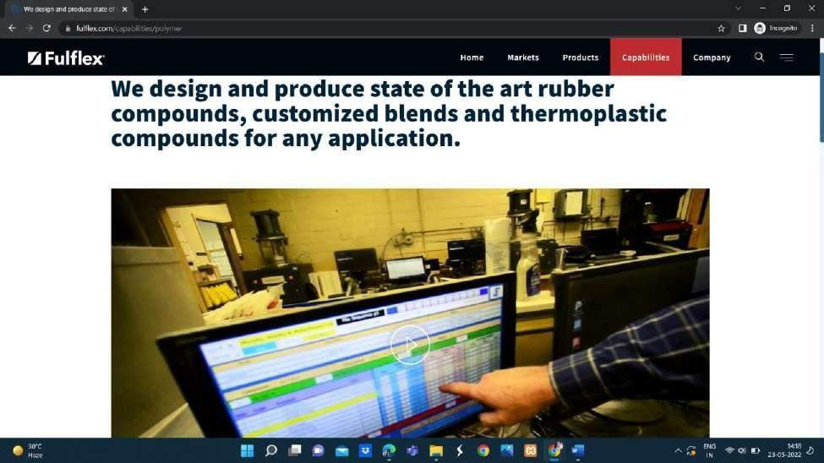

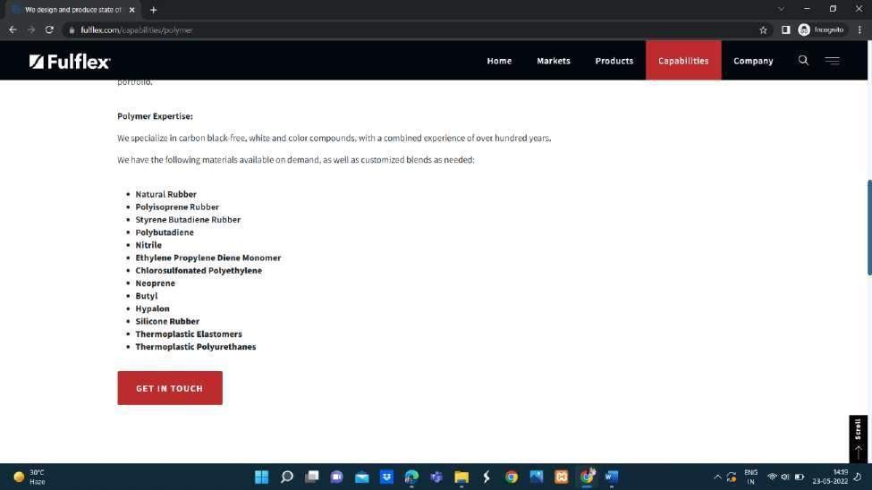

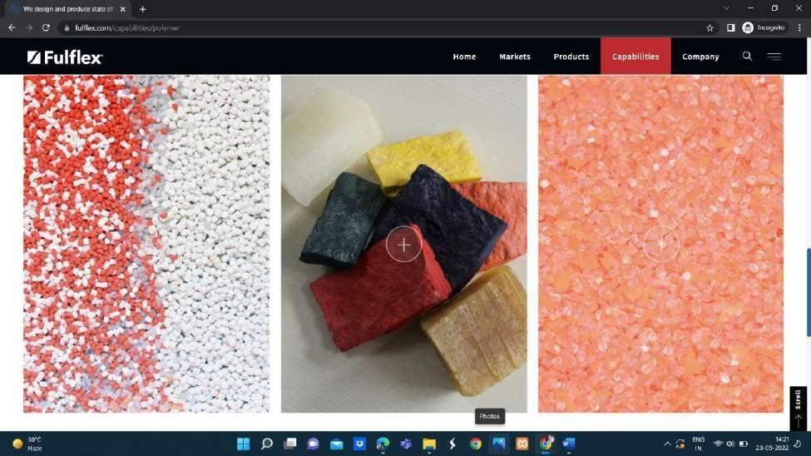

**COMPANY:**

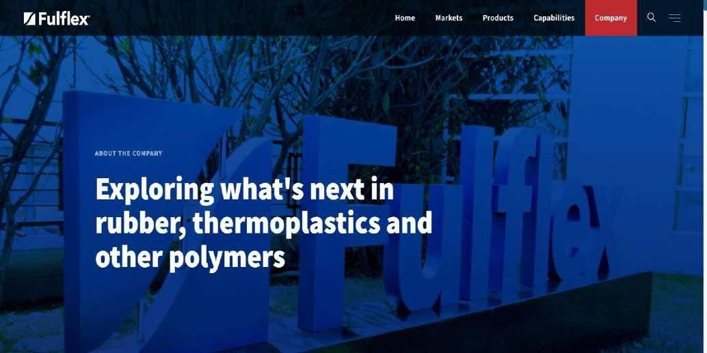

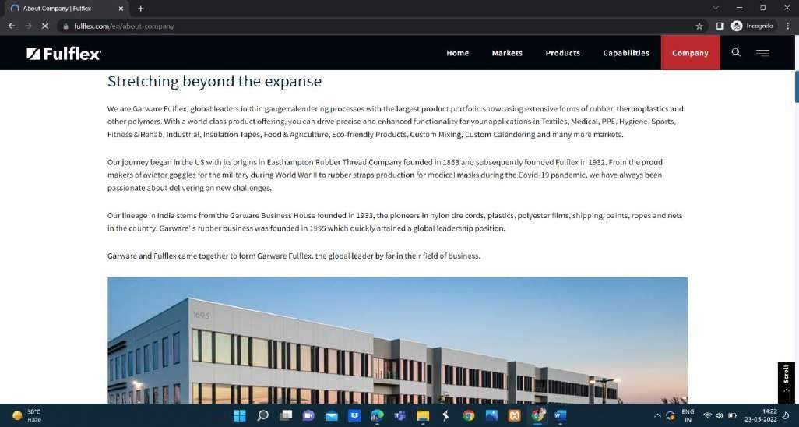

### Vision and Mission

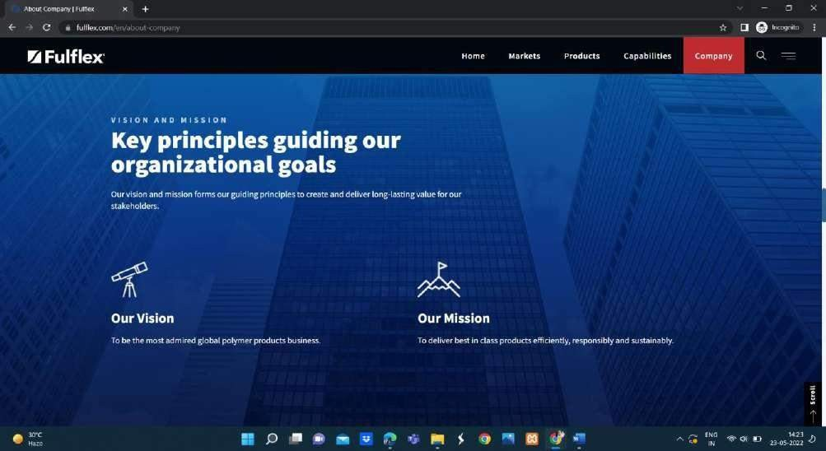

**Our Pillars**

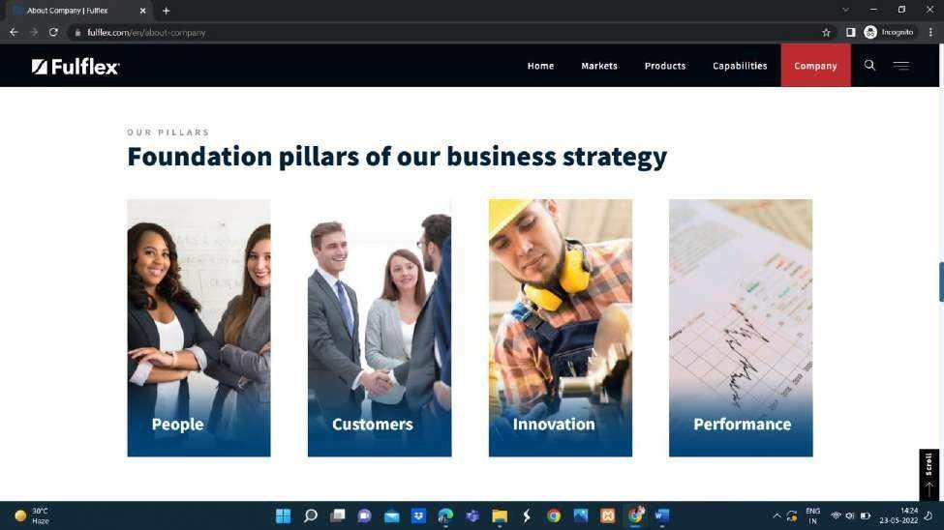

### Awards and Accreditations

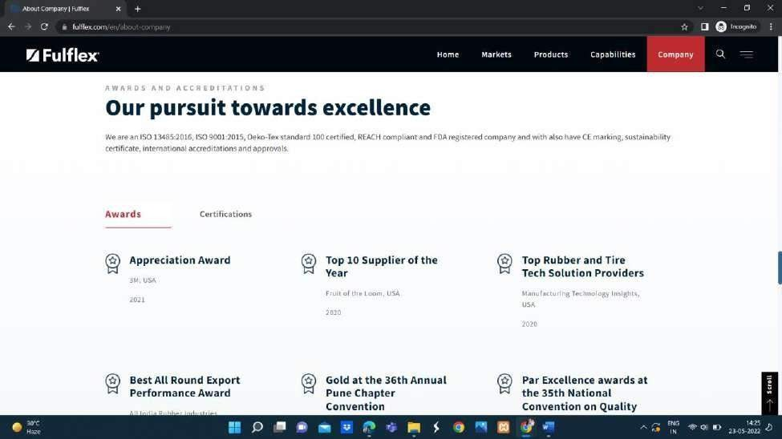

**Our Culture**

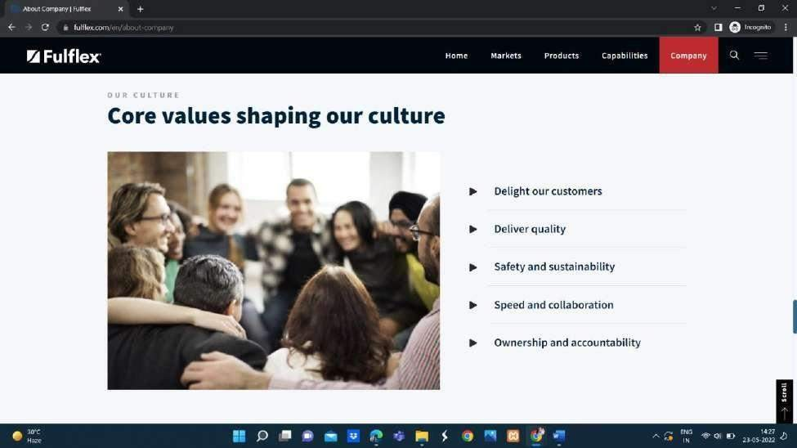

### Global Presence

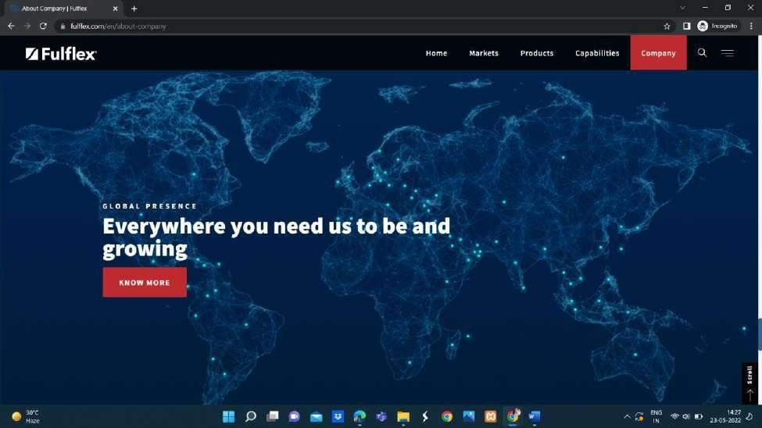

**GET in Touch with us**

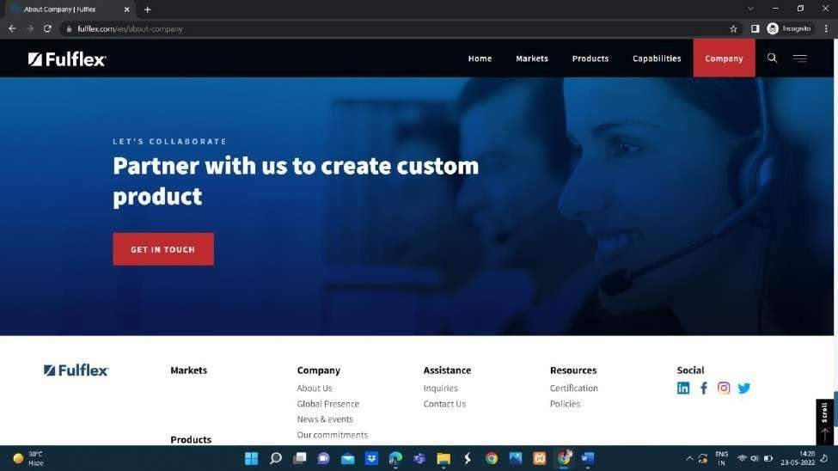

### Sustainability

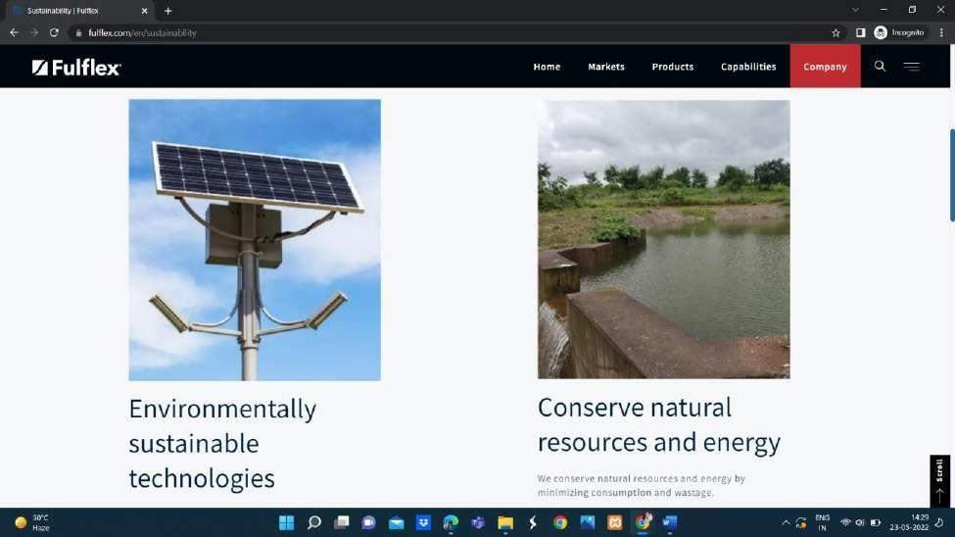

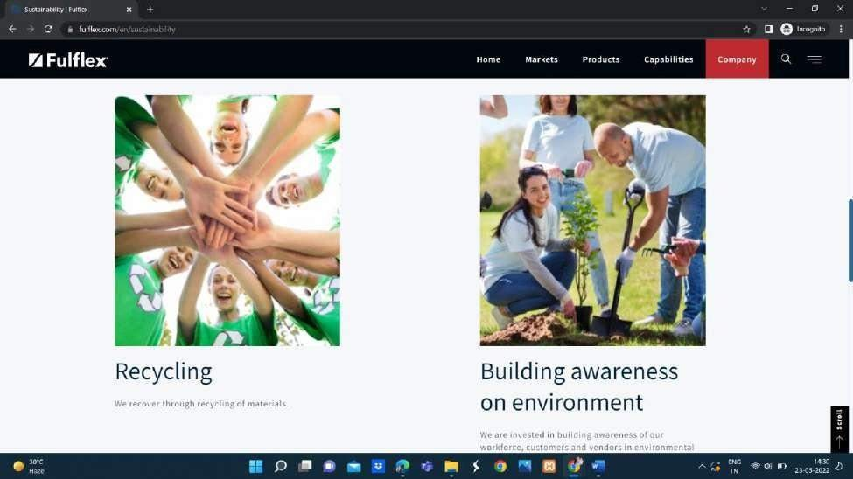

**Key Drivers**

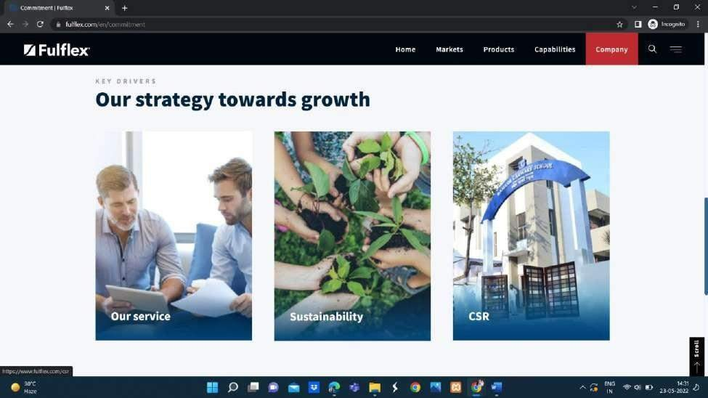

**FOOTER:**

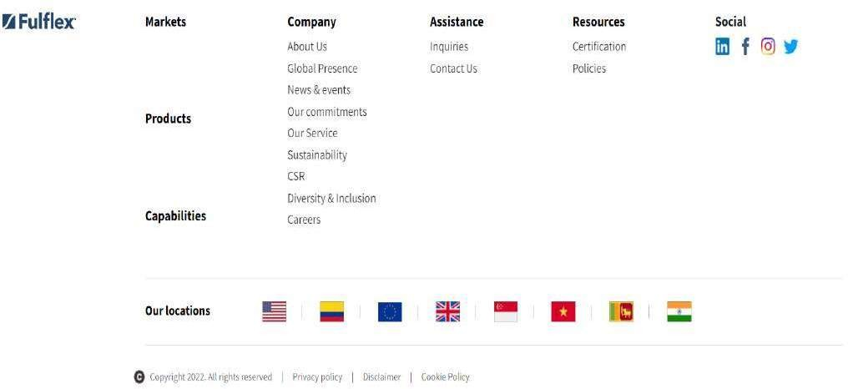

# CHAPTER 5 REPORT/OUTPUT

### STAGE WEBSITE: HOME PAGE:

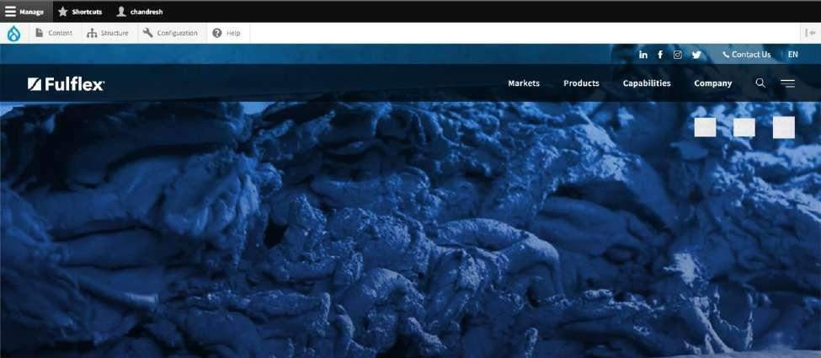

**MARKET PAGE:**

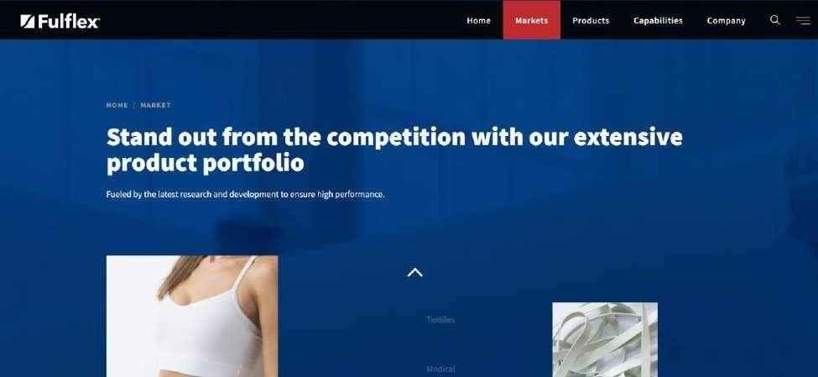

### PRODUCT PAGE:

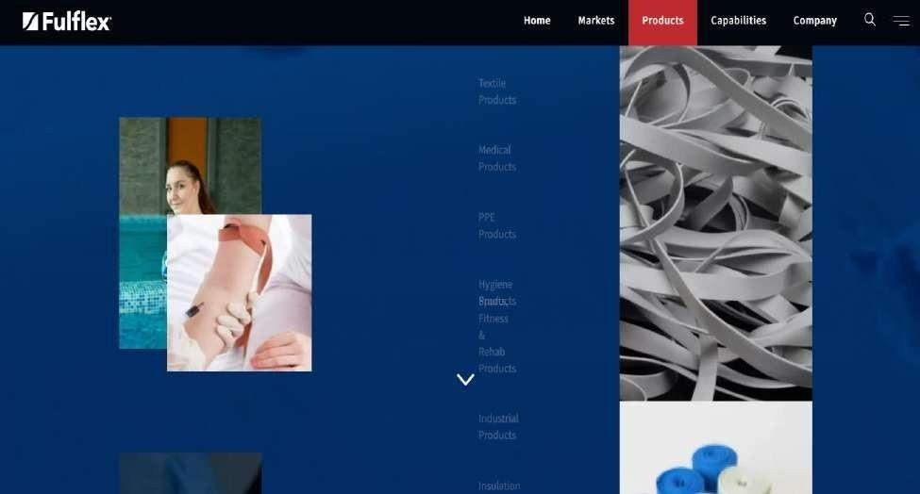

**CAPABILITIES:**

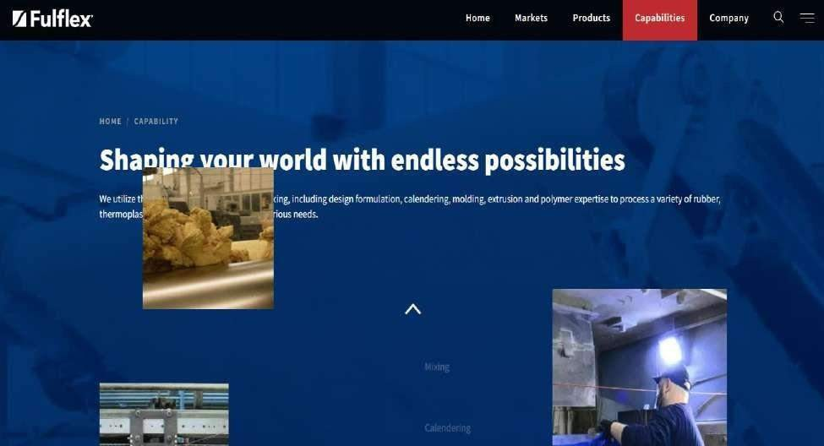

### COMPANY:



**NEWS and Events**

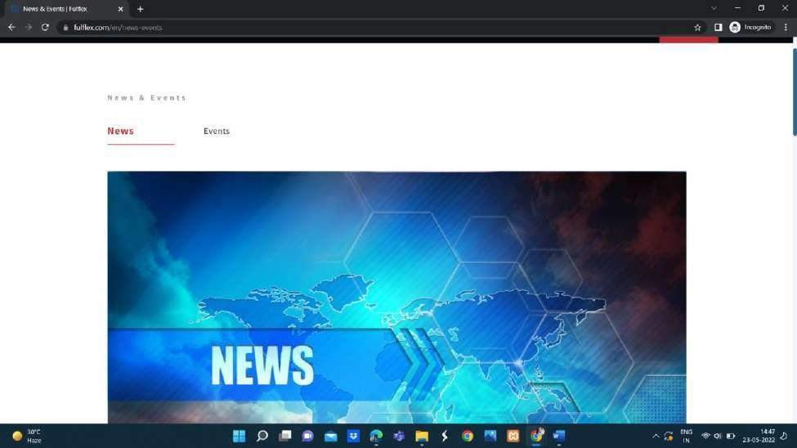

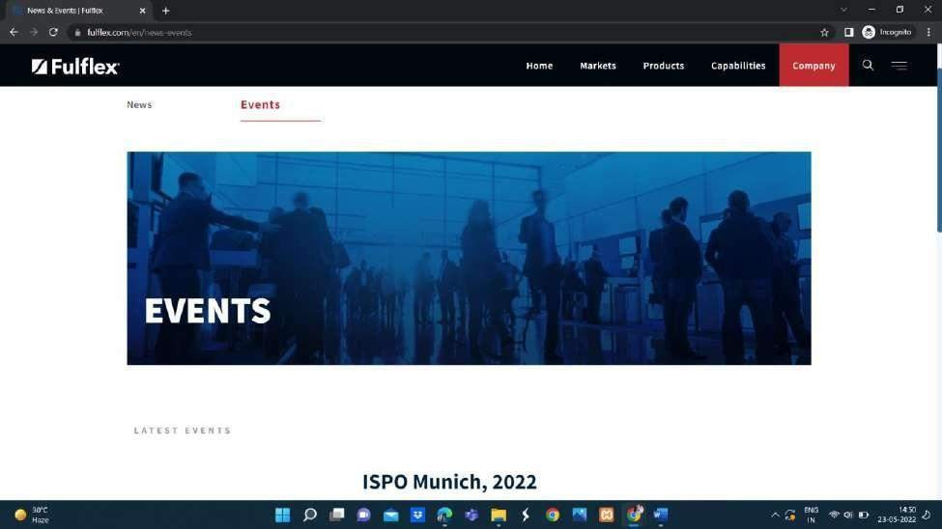

# CHAPTER 6 TESTING

### UNIT TESTING

* + 1. **Introduction**

In computer programming, unit testing is a software testing method by which individual units of source code, sets of one or more computer program modules together with associated control data, usage procedures, and operating procedures, are tested to determine whether they are fit for use. Intuitively, one can view a unit as the smallest testable part of an application. In procedural programming, a unit could be an entire module, but it is more commonly an individual function or procedure. In object- oriented programming, a unit is often an entire interface, such as a class, but could be an individual method. Unit tests are short code fragments created by programmers or occasionally by white box testers during the development process. It forms the basis for component testing. Ideally, each test case is independent from the others. Substitutes such as method stubs, mock objects, fakes, and test harnesses can be used to assist testing a module in isolation. Unit tests are typically written and run by software developers to ensure that code meets its design and behaves as intended.

### Benefits:

The goal of unit testing is to isolate each part of the program and show that the individual parts are correct. A unit test provides a strict, written contract that the piece of code must satisfy. As a result, it affords several benefits.

### Find problems early:

Unit testing finds problems early in the development cycle. In test-driven development (TDD), which is frequently used in both extreme programming and scrum,unit tests are created before the code itself is written. When the tests pass, that code is considered complete. The same unit tests are run against that function frequently as the larger code base is developed either as the code is changed or via an automated process with the build. If the unit tests fail, it is considered to be a bug either in the changed code or the tests themselves.

The unit tests then allow the location of the fault or failure to be easily traced. Since the unit tests alert the development team of the problem before handing the code off to testers or clients, it is still early in the development process.

### Facilitates Change:

Unit testing allows the programmer to refactor code or upgrade system libraries at a later date, and make sure the module still works correctly (e.g., in regression testing). The procedure is to write test cases for all functions and methods so that whenever a change causes a fault, it can be quickly identified. Unit tests detect changes which may break a design contract.

### Simplifies Integration:

Unit testing may reduce uncertainty in the units themselves and can be used in a bottom-up testing style approach. By testing the parts of a program first and then testing the sum of its parts, integration testing becomes much easier.

### Documentation:

Unit testing provides a sort of living documentation of the system. Developers looking to learn what functionality is provided by a unit, and how to use it, can look at the unit tests to gain a basic understanding of the unit's interface (API). Unit test cases embody characteristics that are critical to the success of the unit. These characteristics can indicate appropriate/inappropriate use of a unit as well as negative behaviors that are to be trapped by the unit.

### INTEGRATION TESTING

Integration testing (sometimes called integration and testing, abbreviated I&T) isthe phase in software testing in which individual software modules are combined and tested as a group. It occurs after unit testing and before validation testing. Integration testing takes as its input modules that have been unit tested, groups them in larger aggregates, applies tests defined in an integration test plan to those aggregates, and delivers as its output the integrated system ready for system testing.

**INTEGRATION TESTING** is defined as a type of testing where software modules are integrated logically and tested as a group. A typical software project consists of multiple

software modules, coded by different programmers. The purpose of this level of testing is to expose defects in the interaction between these software modules when they are integrated Integration Testing focuses on checking data communication amongst these modules. Hence it is also termed as **‘I & T’**

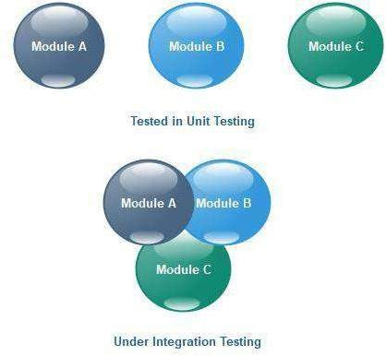

### Purpose

The purpose of integration testing is to verify functional, performance, and reliability requirements placed on major design items. These "design items", i.e., assemblages (or groups of units), are exercised through their interfaces using black-box testing, success and error cases being simulated via appropriate parameter and data inputs. Simulated usage of shared data areas and inter-process communication is tested and individual subsystems are exercised through their input interface. Test cases are constructed to test whether all the components within assemblages interact correctly, for example across procedure calls or process activation, and this is done after testing individual modules, i.e., unit testing. The overall idea is a "building block" approach, in which verified assemblages are added to a verified base which is then used to support the integration testing of further assemblages. Software integration testing is performed according to the software development life cycle (SDLC) after module and functional tests. The cross dependencies for software integration testing are: schedule for integration testing, strategy and selection of the tools used for integration, define the cyclomatic complexity of the software and software architecture, reuse-ability ofmodules and life-cycle and versioning management. Some different types of integration testing are big-bang, top-down, and bottom-up, mixed (sandwich) and risky- hardest. Other Integration Patterns [2] are: collaboration integration, backbone integration,

layer integration, client-server integration, distributed services integration and high-frequency integration.

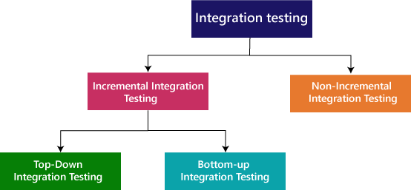

### Bang

Big In the big-bang approach, most of the developed modules are coupled together to form a complete software system or major part of the system and then used for integration testing. This method is very effective for saving time in the integration testing process. However, if the test cases and their results are not recorded properly, the entire integration process will be more complicated and may prevent the testing team from achieving the goal of integration testing. A type of big-bang integration testing is called "usage model testing" which can be used in both software and hardware integration testing. The basis behind this type of integration testing is to run user-like workloads in integrated user-like environments. In doing the testing in this manner, the environment is proofed, while the individual components are proofed indirectly through their use. Usage Model testing takes an optimistic approach to testing, because it expects to have few problems with the individual components. The strategy relies heavilyon the component developers to do the isolated unit testing for their product. The goalof the strategy is to avoid redoing the testing done by the developers, and instead flesh- out problems caused by the interaction of the components in the environment.

### Top-down And Bottom-up

Bottom-up testing is an approach to integrated testing where the lowest level components are tested first, then used to facilitate the testing of high level components. The process is repeated until the component at the top of the hierarchy is tested. All the bottom or low-level modules, procedures or functions are integrated and then tested. After the integration testing of low level integrated modules, the next level of modules will be formed and can be used for integration testing. This approach is helpful only when all or most of the modules of the same development level are ready. This method also helps to determine the levels of software developed and makesit easier to report testing progress in the form of a percentage. Top-down testing is an approach to integrated testing where the top integrated modules are tested and the branch of the module is tested step by step until the end of the related module. Sandwich testing is an approach to combine top-down testing with bottom-up testing.

### Performance Testing:

Performance testing is a non-functional [software testing](https://www.microfocus.com/products/performance-engineering/overview) technique that determines how the stability, speed, scalability, and responsiveness of an application holds up under a given workload. It’s a key step in ensuring software quality, but unfortunately, is often seen as an afterthought, in

isolation, and to begin once functional testing is completed, and in most cases, after the code is ready to release.

The goals of [performance testing](https://www.microfocus.com/solutions/performance-testing) include evaluating application output, processing speed, data transfer velocity, network bandwidth usage, maximum concurrent users, memory utilization, workload efficiency, and command response times.

### How to Do Performance Testing?

The specific steps of performance testing will vary from one organization and application to the next. It depends on what performance indicators the business considers most important. Nevertheless, the general goals of performance testing are largely the same across the board so there’s a certain workflow most testing plans will follow.

### Define Acceptable Performance Criteria

Determine the constraints, goals, and thresholds that will demonstrate test success. The major criteria will be derived directly from the project specifications, but testers should be adequately empowered to set a wider set of tests and benchmarks.

### Plan and Design Tests

Think about how widely usage is bound to vary then create test scenarios that accommodate all feasible use cases. Design the tests accordingly and outline the metrics that should be captured.

### Prepare Test Environment and Tools

Configure the testing environment before you execute the performance tests. Assemble your testing tools in readiness.

### Run the Performance Tests

Execute the tests. Capture and monitor the results.

### Resolve and Retest

Consolidate and analyze test results. Share the findings with the project team. Fine tune the application by resolving the performance shortcomings identified. Repeat the test to confirm each problem has been conclusively eliminated.

### SOFTWARE VERIFICATION AND VALIDATION

* + 1. **Introduction**

In software project management, software testing, and software engineering, verification and validation (V&V) is the process of checking that a software system meets specifications and that it fulfills its intended purpose. It may also be referred to as software quality control. It is normally the responsibility of software testers as part of the software development life-cycle. Validation checks that the product design satisfies or fits the intended use (high-level checking), i.e., the software meets the user requirements. This is done through dynamic testing and other forms of review. Verification and validation are not the same thing, although they are often confused. Boehm succinctly expressed the difference between Validation: Are we building the

right product?

Verification: Are we building the exact product?

According to the Capability Maturity Model (CMMI-SW v1.1)

Software Verification: The process of evaluating software to determine whether the products of a given development phase satisfy the conditions imposed at the start of that phase.

Software Validation: The process of evaluating software during or at the end of the development process to determine whether it satisfies specified requirements. In other words, software verification is ensuring that the product has been built according to the requirements and design specifications, while software validation ensures that the product meets the user's needs, and that the specifications were correct in the first place.

Software verification ensures that "you built it right". Software validation ensures that "you built the right thing". Software validation confirms that the product, as provided, will fulfill its intended use.

From Testing Perspective

Fault – wrong or missing function in the code.

Failure – the manifestation of a fault during execution.

Malfunction – according to its specification the system does not meet its specified functionality.

Both verification and validation are related to the concepts of quality and of software quality assurance. By themselves, verification and validation do not guarantee software quality; planning, traceability, configuration management and other aspects of software engineering are required.Within the modeling and simulation (M&S)community, the definitions of verification, validation and accreditation are similar:

M&S Verification is the process of determining that a computer model, simulation, or federation of models and simulations implementations and their associated data accurately represent the developer's conceptual description and specifications.

M&S Validation is the process of determining the degree to which a model, simulation, or federation of models and simulations, and their associated data are accurate representations of the real world from the perspective of the intended use(s).

### Classification of Methods

In mission-critical software systems, where flawless performance is absolutely necessary, formal methods may be used to ensure the correct operation of a system. However, often for non-mission critical software systems, formal methods prove to be very costly and an alternative method of software V&V must be sought out. In such cases, syntactic methods are often used.

### Test Cases

A test case is a tool used in the process. Test cases may be prepared for software verification and software validation to determine if the product was built according to the requirements of the user. Other methods, such as reviews, may be used

early in the life cycle to provide for software validation.

### Black-Box Testing

Black-box testing is a method of software testing that examines the functionality of an application without peering into its internal structures or workings. This method of test can be applied virtually to every level of software testing: unit, integration, system and acceptance. It typically comprises most if not all high level testing, but can also dominate unit testing as well.

### Test Procedures

Specific knowledge of the application's code/internal structure and programming knowledge in general is not required. The tester is aware of what the software is supposed to do but is not aware of how it does it. For instance, the tester is aware that a particular input returns a certain, invariable output but is not aware of how the software produces the output in the first place.

### Test Cases

Test cases are built around specifications and requirements, i.e., what the application is supposed to do. Test cases are generally derived from external descriptions of the software, including specifications, requirements and design parameters. Although the tests used are primarily functional in nature, non-functional tests may also be used. The test designer selects both valid and invalid inputs and determines the correct output, often with the help of an oracle or a previous result that is known to be good, without any knowledge of the test object's internal structure.

### White-Box Testing

White-box testing (also known as clear box testing, glass box testing, transparent box testing, and structural testing) is a method of testing software that tests internal structures or workings of an application, as opposed to its functionality (i.e. black-box testing). In white-box testing an internal perspective of the system, as well as programming skills, are used to design test cases. The tester chooses inputs to exercise paths through the code and determine the appropriate outputs. This is analogous to testing nodes in a circuit, e.g. in-circuit testing (ICT). White-box testing can be applied at the unit, integration and system levels of the software testing process. Although traditional testers tended to think of white-box testing as being done at the unit level, it

is used for integration and system testing more frequently today. It can test paths within a unit, paths between units during integration, and between subsystems during a system–level test. Though this method of test design can uncover many errors or problems, it has the potential to miss unimplemented parts of the specification or missing requirements.

### Levels

1. **Unit Testing:**

White-box testing is done during unit testing to ensure that the code is working as intended, before any integration happens with previously tested code.

White-box testing during unit testing catches any defects early on and aids in any defects that happen later on after the code is integrated with the rest of the application and therefore prevents any type of errors later on.

### Integration Testing:

White-box testing at this level are written to test the interactions of each interface with each other. The Unit level testing made sure that each code was tested and working accordingly in an isolated environment and integration examines the correctness of the behavior in an open environment through the use of white-box testing for any interactions of interfaces that are known to the programmer.

### Regression Testing:

White-box testing during regression testing is the use of recycled white- box testcases at the unit and integration testing levels.

### Procedures

White-box testing basic procedures involves the tester having a deep level of understanding of the source code being tested. The programmer must have a deep understanding of the application to know what kinds of test cases to create so that every visible path is exercised for testing. Once the source code is understood then then source

code can be analyzed for test cases to be created. These are the three basic steps that white-box testing takes in order to create test cases:

Input involves different types of requirements, functional specifications, detailed designing of documents, proper source code, security specifications. This is the preparation stage of white-box testing to layout all of the basic information. Processing involves performing risk analysis to guide whole testing process, proper test plan, execute test cases and communicate results. This is the phase of building test cases to make sure they thoroughly test the application the given results are recorded accordingly.

Output involves preparing final report that encompasses all of the above preparations and results.

### Results of Performance Testing HOME PAGE:

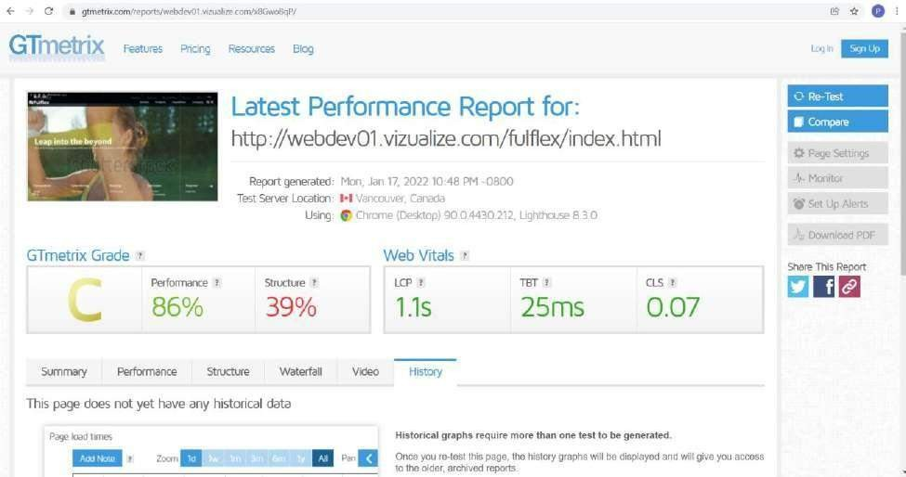

**MARKET PAGE:**

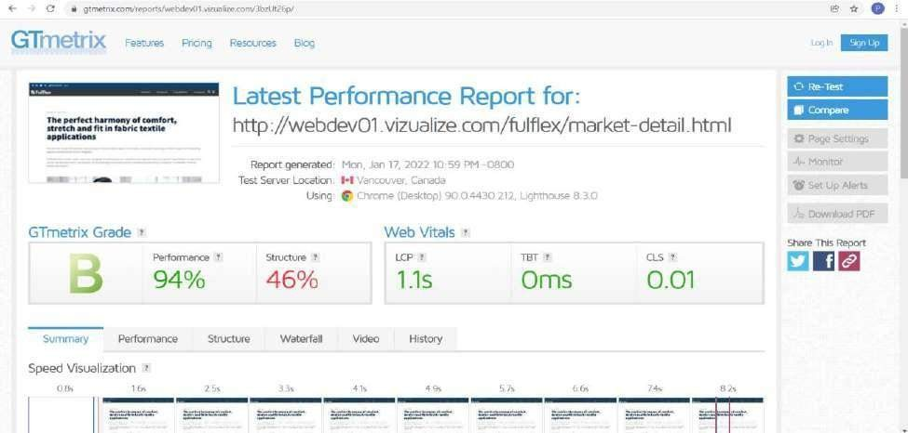

### PRODUCT PAGE:

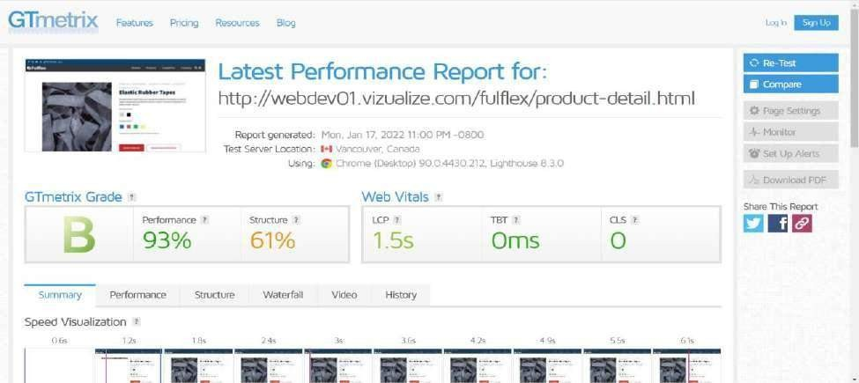

**CAPABILITIES PAGE:**

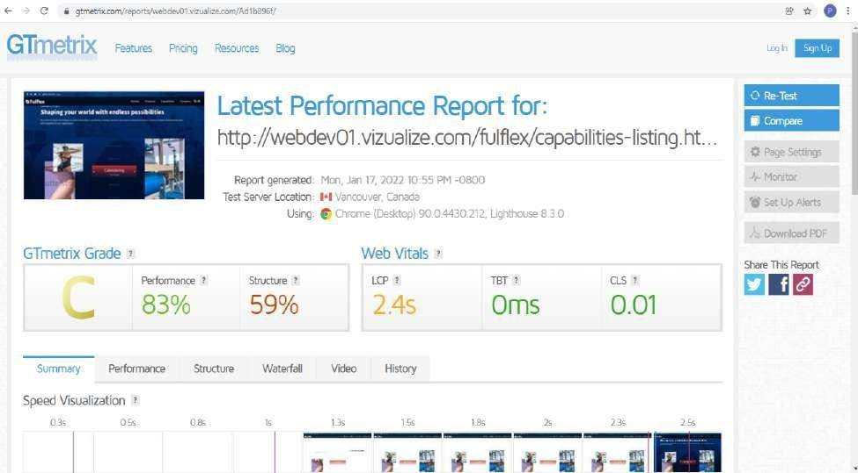

### COMPANY PAGE:

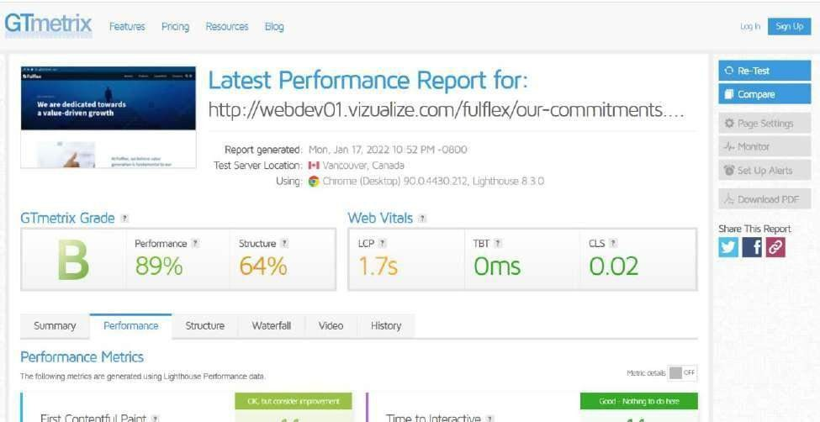

**CSR PAGE:**

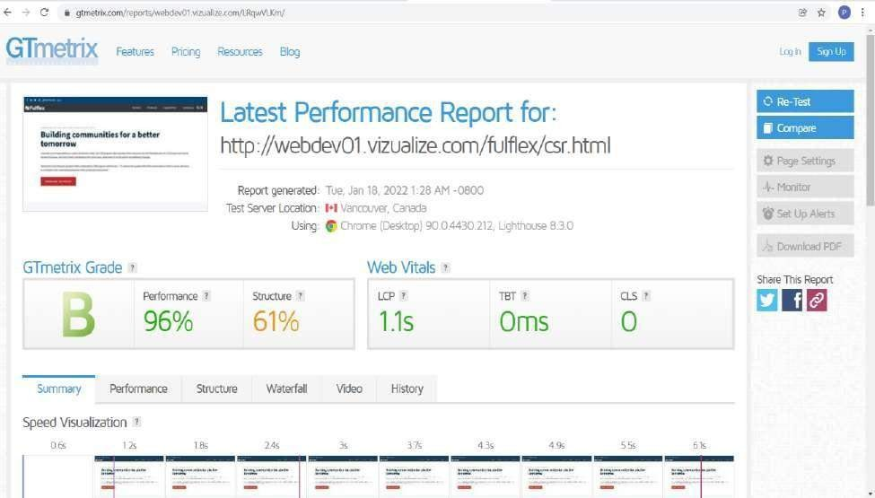

# CHAPTER 7 LIMITATION

### FUTURE SCOPE

**Key principles guiding our organizational goals**

Our vision and mission form our guiding principles to create and deliver long lasting value for our stakeholders.

### Our Vision

To be the most admired global polymer products business.

### Our Mission

To deliver best in class products efficiently, responsibly and sustainably. At Fulflex , we believe value creation is fundamental to growth.

We will continuously strive to create value for all our stakeholders.

We stand committed to supporting our community through education and health care. We take pride in nurturing and sustaining our environment through our eco-friendly initiatives.

### FUTURE ENHANCEMENT

Our world class manufacturing facilities in USA and India are equipped with cutting edge expertise in Mixing, Calendering , Molding, Extrusion and Polymer and are designed to meet the highest standards in quality, safety and sustainability. A strong commitment to research and development fosters a strong culture of innovation that allows us to meet the changing needs of the global market.

As a responsible leader, Fulflex is committed to implementing sustainable practices towards minimizing its carbon footprint and impact on the environment. The future is ours to shape. The future is Fulflex.

### SYSTEM TESTING

System testing of software or hardware is testing conducted on a complete, integrated system to evaluate the system's compliance with its specified requirements. System testing falls within the scope of black-box testing, and as such, should require knowledge of the inner design of the code or logic. As a rule, system testing takes, asse t, input, all of the "integrated" software components that have passed integration testing and also the

software system itself integrated with any applicable hardware system(s).

The purpose of integration testing is to detect any inconsistencies between the software units that are integrated together (called assemblages) or between any of the assemblages and the hardware. System testing is a more limited type of testing; it seeks to detect defects both within the "inter- assemblages" and also within the system as a whole.

System testing is performed on the entire system in the context of a Functional Requirement Specification(s) (FRS) and/or a System Requirement Specification (SRS). System testing tests not only the design, but also the behavior and even the believed expectations of the customer. It is also intended to test up to and beyond the bounds defined in the software/hardware requirements specification(s).

# CHAPTER 8 CONCLUSION

Our journey began in the US with its origins in Easthampton Rubber Thread Company founded

in 1863 and subsequently founded Fulflex in 1932. From the proud makers of aviator goggles for the military during World War II to rubber straps production for medical masks during the Covid-19 pandemic, we have always been passionate about delivering on new challenges.

Our lineage in India stems from the Garware Business House founded in 1933, the pioneers in nylon tire cords, plastics, polyester films, shipping, paints, ropes and nets in the country.

Garware’ s rubber business was founded in 1995 which quickly attained a global leadership position.

Garware and Fulflex came together to form Garware Fulflex, the global leader by far in their field of business.

# CHAPTER 9 REFERENCE

[1]

Yaish, H., Goyal, M., & Feuerlicht, G. (2014). Evaluating the performance of multitenant elastic extension tables. Procedia Computer Science, 29, 614-626.

1. Peng, J., Zhang, X., Lei, Z., Zhang, B., Zhang, W., & Li, Q. (2009, December). Comparison of several cloud computing platforms. In 2009 Second international symposium on information science and engineering (pp. 23-27). IEEE.
2. Li, M., Kankanhalli, A., & Kim, S. H. (2016). Which ideas are more likely to be implemented in online user innovation communities? An empirical analysis. Decision Support Systems, 84,

28-40

1. Kovach, J. J., Atasu, A., & Banerjee, S. (2018). Salesforce incentives and remanufacturing. Production and Operations Management, 27(3), 516-530.
2. Ntayi, J. M., Munene, J. C., & Eyaa, S. (2010). Salesforce behavioural performance of accounts relationship managers (ARMS) in Uganda's commercial banks: A qualitative analysis.

Journal of Retail & Leisure Property, 9(1), 5-23

1. Anderson, E., & Oliver, R. L. (1987). Perspectives on behavior-based versus outcomebased salesforce control systems. Journal of Marketing, 51(4), 76-88.
2. Samaraweera, M., & Gelb, B. D. (2015). Formal salesforce controls and revenue production: a meta-analysis. Journal of Personal Selling & Sales Management, 35(1), 23- 32.
3. Mason, M. (2018). Overcoming the risks of privileged user abuse in Salesforce. Network Security, 2018(8), 6-8
4. Fisher, S. (2007, May). The architecture of the apex platform, salesforce. com's platform for building on-demand applications. In 29th International Conference on Software Engineering (ICSE'07 Companion) (pp. 3-3). IEEE.
5. Espadas, J., Concha, D., & Molina, A. (2008, October). Application Development over Software-as-a-Service platforms. In 2008 the third international conference on software engineering advances (pp. 97-104). IEEE. 63
6. Churchill Jr, G. A., Ford, N. M., & Walker Jr, O. C. (1976). Organizational climate and job satisfaction in the salesforce. Journal of Marketing Research, 13(4), 323-332.
7. Dai, Y., & Chao, X. (2016). Price delegation and salesforce contract design with asymmetric risk aversion coefficient of sales agents. International Journal of Production Economics, 172, 31-42.
8. Mietzner, R., & Leymann, F. (2010, December). A self-service portal for service-based applications. In 2010 IEEE International Conference on Service-Oriented Computing and Applications (SOCA) (pp. 1-8). IEEE.
9. Hayes, B. (2008). Cloud computing.
10. Netto, M.; Calheiros, R.; Rodrigues, E.; Cunha, R.; Buyya, R. (2018). "HPC Cloud for Scientific and Business Applications: Taxonomy, Vision, and Research Challenges". ACM Computing Surveys. 51 (1): 8:1–8:29